Specific Gravity of Soil Solids

- Introduction
Specific gravity, G_{s}, is defined as the ratio of the unit weight of a given material to the unit weight of water. The general ranges of the values of G_{s} are from 2.6 to 2.9. Table 1.1 gives the values of G_{s} for various soils. The method listed here is only applicable for soils that pass No. 4 U.S. sieve.

Soil Type | Range of G_{s}
Sand | 2.63 – 2.67
Silts | 2.65 – 2.7
Clay and silty clay | 2.67 – 2.9
Organic soil | < 2.0
Table 1.1: The ranges of G_{s}

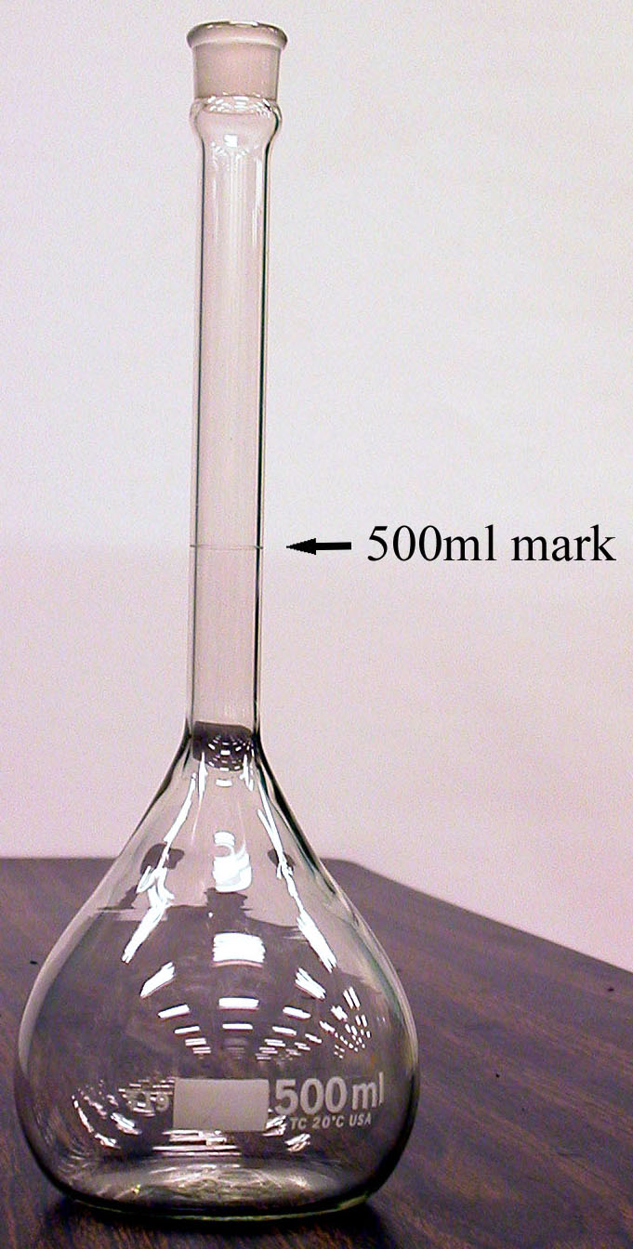
- ASTM D-854

- Apparatus
- Volumetric flask: 500ml
- Thermometer
- Spatula
- Drying oven
- Evaporating dishes
- Sieve: No. 4 (4.75mm)
- Plastic squeeze bottle

Figure 1.1: Flask
- Aspirator: To remove entrapped air in water.
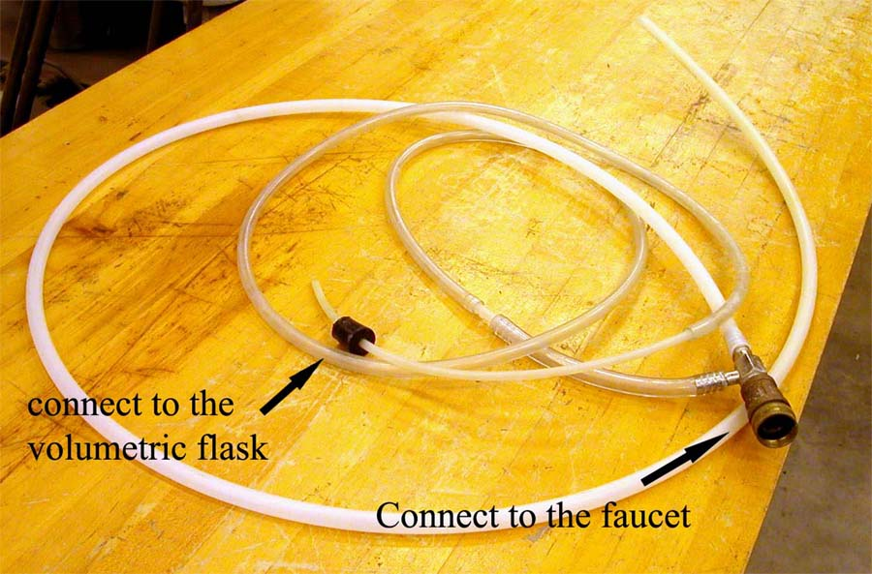

Figure 1.2: Aspirator

- Balance: The balance need to have a readability of 0.01 g and capacity of at least 2000 g.

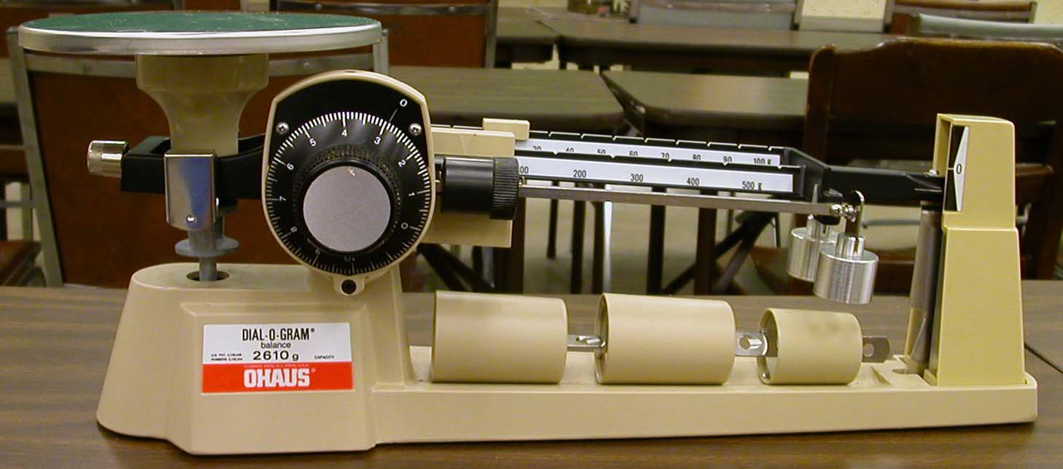
Figure 1.3: Balance

- Actual Procedure

  - Clean the volumetric flasks and dry them.
  - Fill the flask No. 1 with water (tap water is accepted here) up to the 500 ml mark (bottom of the meniscus should be at the 500 ml mark).
  - Use a balance to determine the mass of the flask No. 1 (W₁) with the water filled to the 500 ml mark.
  - Use the thermometer to determine the temperature of water in the flask No.1 (T₁ ºC)
  - Put 100 grams of air-dry soil that passes the No. 4 U.S. sieve into an evaporating dish.
  - If the soil is cohesive, mix the soil with water to the form of a smooth paste and let it soaked for about half to one hour. If the soil is granular, then skip this step.
  - Put the soil in to the volumetric flask No. 2.
  - Pour water into the volumetric flask No.2 to make it about two-third full.
  - Connect one end of the aspirator to the faucet and another end to the volumetric flask No. 2. Turn the faucet on. Then use the aspirator to remove the air entrapped in the water mixed with soil (Make sure that the entrapped air is removed thoroughly).
  - Make sure that the temperature of the water-soil mixture in the volumetric flask No. 2 is equal to the room temperature (T₁ ºC).
  - Pour more water into the volumetric flask No. 2 to the 500 ml mark.
  - Weigh the volumetric flask No. 2 with soil and water (W₂).
  - Pour the content of the volumetric flask No. 2 completely into an evaporating dish. Make sure that there is no soil left in it (use the plastic squeeze bottle).
  - Use the oven to dry the soil.
  - Weigh the dry soil in the evaporating dish (W_{s}).

- Calculation and Formula

Calculate the specific gravity, G_{s}:

G_{s} (at T₁ ºC) = W_{s} / W_{w}
W_{s} = the mass of the soil
W_{w} = (W₁ + W_{s}) – W₂, the mass of equal volume of water

Specific gravity is usually reported at the temperature of 20 ºC. So we need to convert the G_{s} (at T₁ ºC) to the G_{s} (at 20 ºC).

G_{s} (at 20 ºC) = G_{s} (at T₁ ºC) * A

The values of A are listed in the table 1.2

Temperature (T₁ ºC) | A | Temperature (T₁ ºC) | A
16 | 1.0007 | 24 | 0.9991
17 | 1.0006 | 25 | 0.9988
18 | 1.0004 | 26 | 0.9986
19 | 1.0002 | 27 | 0.9983
20 | 1.0000 | 28 | 0.9980
21 | 0.9998 | 29 | 0.9977
22 | 0.9996 | 30 | 0.9974
23 | 0.9993
Table 1.2 Values of A

- Sample Report

Specific Gravity of Soil Solids
Description of soil |  | Specimen No.
Volume of flask at 20 ºC ml | Temperature of solution ºC
A (Table 1.2)
Location
Tested by |  | Date
Item |  | Test No.
 | 1 | 2 | 3
Volumetric flask No.
Mass of flask + water filled to mark, W₁ (g)
Mass of flask + soil + water filled to mark, W₂ (g)
Mass of dry soil, W_{s} (g)
Mass of equal volume of water as the soil solids, W_{w} (g) = (W₁+W_{s}) - W₂
G_{s(T1} o_{C)} = W_{s} / W_{w}
G_{s(20} o_{C)} = G_{s(T1} o_{C)} * A
Average G_{s}

