Mechanical Analysis of Soil
Mechanical analysis is the determination of the size range of particles present in a soil, expressed as a percentage of the total dry weight. There are two methods usually used to find the particle-size distribution of soil. First one is sieve analysis, gradation. The second one is hydrometer analysis.
II.a Gradation (Sieve Analysis)

- Introduction
Sieve analysis consists of shaking the soil sample through a set of sieves that have progressively smaller openings. The table 2.1 lists U.S. standard sieve numbers and the sizes of openings. The method of sieve analysis is applicable for soils that are mostly granular with some or no fines.

Sieve No. | Opening (mm)
4 | 4.750
8 | 2.360
10 | 2.000
20 | 0.850
40 | 0.425
60 | 0.250
80 | 0.180
100 | 0.150
120 | 0.125
200 | 0.075
Table 2a.1: Sieve number and size of
opening
- ASTM D-422
- Apparatus
- Sieves (No. 4, 8, 20, 40, 80, 120, 200), a bottom pan, and a cover
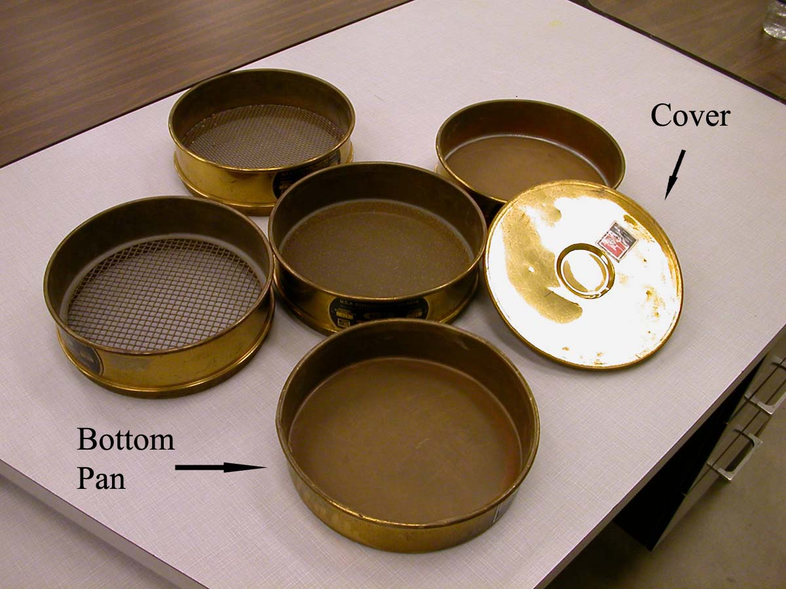
Figure 2a.1: Sieves, pan, and cover

- Balance
- Mortar and pestle
- Oven
- Mechanical sieve shaker
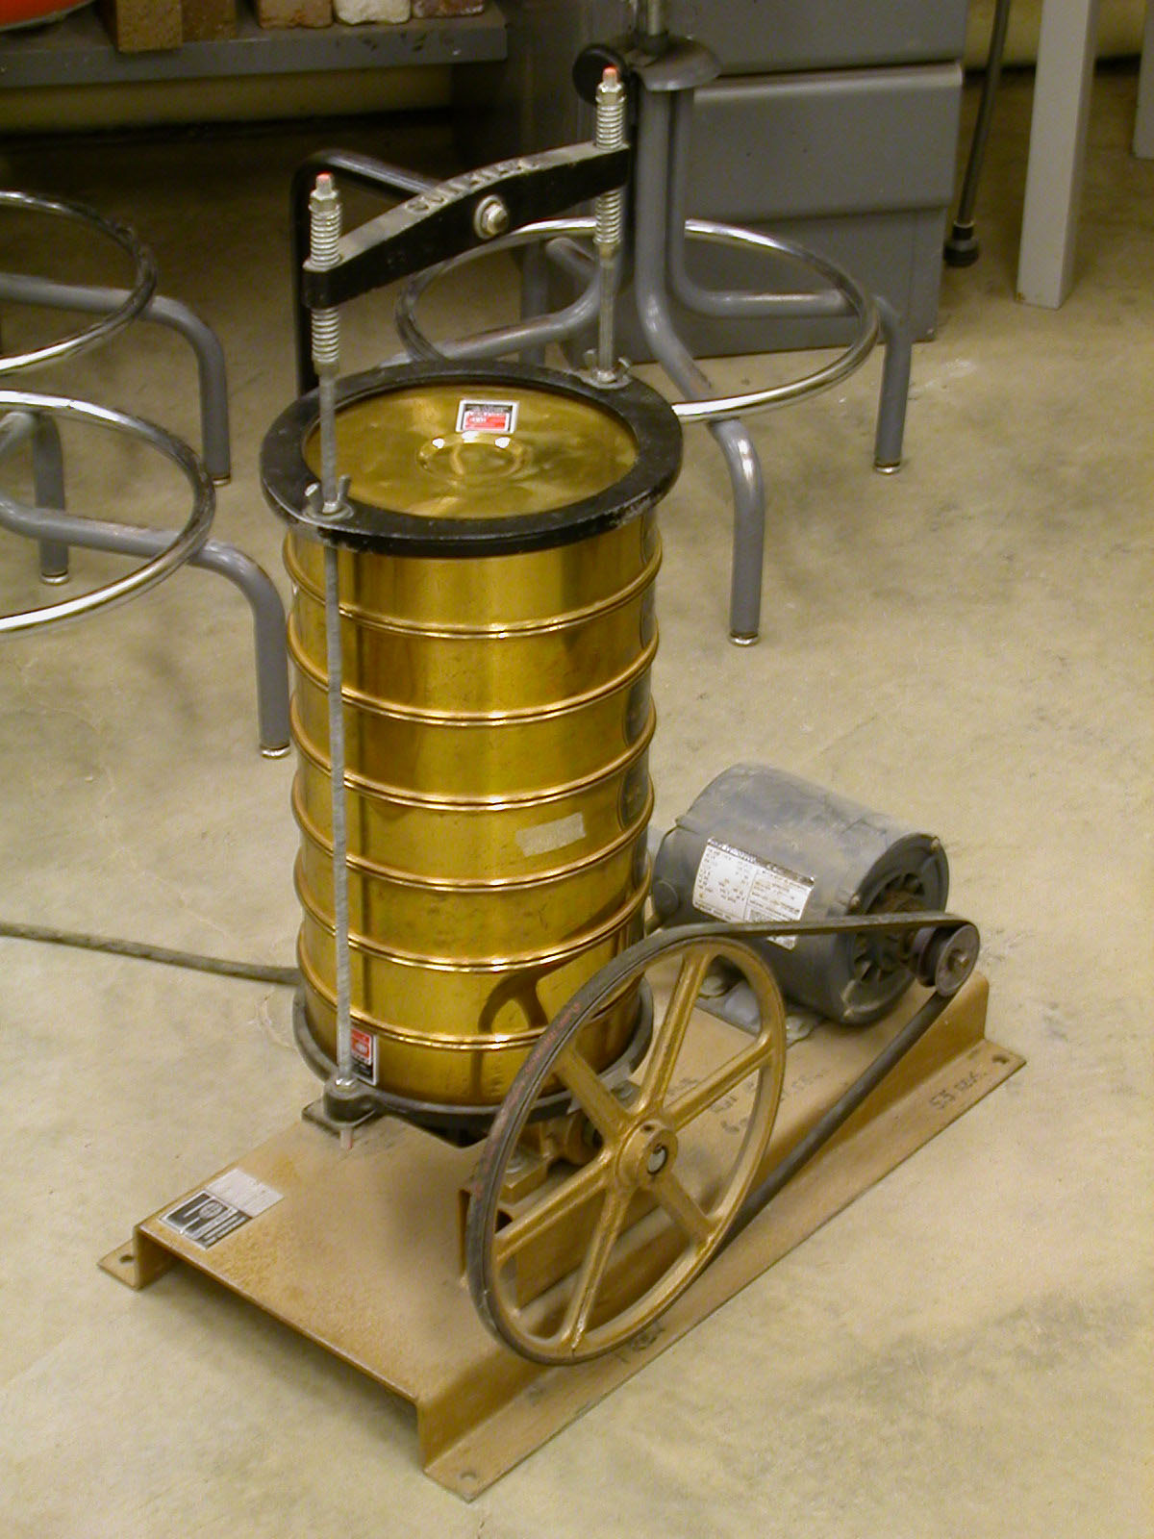

Figure 2a. 2: Sieves shaker
- Actual Procedure
  - Collect oven dry soil sample about 500 grams.
  - Use a mortar to break the soil sample into smaller pieces.
  - Use a balance to weigh the soil sample (W).
  - Prepare a stack of sieves. Place a sieve with larger opening above a sieve with smaller opening. The top one should be No. 4 sieve and the bottom one should be No. 200 sieve. Place a bottom pan under a No. 200 sieve. The sieves that are used in our laboratory in a stack are Nos. 4, 8, 20, 40, 80, 120, and 200.

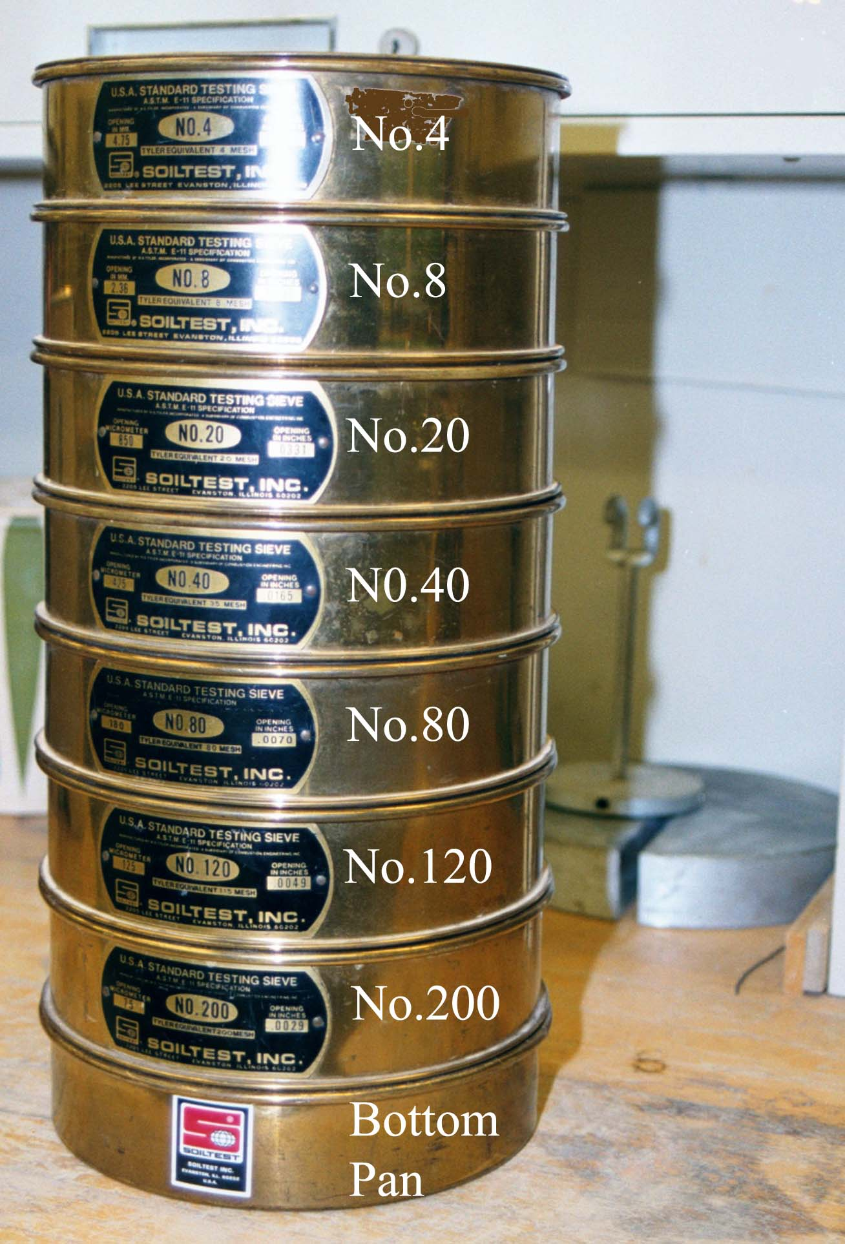
Figure 2a.3: Stack of sieves

  - Pour the soil sample into the stack of sieves from the top.
  - Place the cover on the top of the stack of sieves.
  - Run the stack of sieves through a sieve shaker for 15 minutes.
  - Weigh the amount of soil retained on each sieve and the bottom pan.
- Calculation and Formula

    - Calculate the percent of soil retained on the n^{th} sieve, R_{n} (counting from the top).
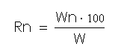

W_{n} is the mass retained on the n^{th} sieve.
W is the total mass of soil sample.
    - Calculate the cumulative percent of soil retained on the n^{th} sieve.
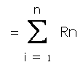

    - Calculate the cumulative percent passing through the n^{th} sieve.
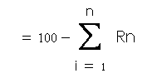

    - Plot the percent finer vs. grain size graph (figure 2a.4) on a semi-logarithmic graph paper. The grain size is plotted on the log scale and the percent finer is plotted on the natural scale.
    - Determine D₁₀, D₃₀, and D₆₀, which are the diameters corresponding to percents finer of 10%, 30%, and 60%.
    - Calculate the uniformity coefficient (C_{u}) and the coefficient of gradation (C_{c}).
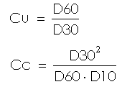

- Sample Report

Sieve Analysis
Description of soil Sample No. .
Mass of oven dry specimen, W g. |  |  |  | Location .
Tested by . Date .
Sieve No. | Sieve opening (mm) | Mass of soil retained on each sieve, W_{n} | Percent of mass retained on each sieve, R_{n} | Cumulative percent retained ΣR_{n} | Percent finer, 100 - ΣR_{n}
No.4 | 4.750
No.8 | 2.360
No.20 | 0.850
No.40 | 0.425
No.80 | 0.180
No.120 | 0.125
No.200 | 0.075
Pan

- Sample Graph

Figure 2a.4: percent finer vs. grain size

