II.b Hydrometer Analysis

- Introduction
Hydrometer analysis is based on the principle of sedimentation of soil grains in water. When a soil specimen that is finer than No. 200 sieve is dispersed in water, the particles settle at different velocities, depending on their shape, size, weight, and the viscosity of the water. It is assumed that all the soil particles are spheres and the velocity of soil particles can be expressed by stokes’ law.
The ASTM 152-H type of hydrometer (figure 2b.1) will be used for this test. The table 2b.1 lists the hydrometer reading and the corresponding L.

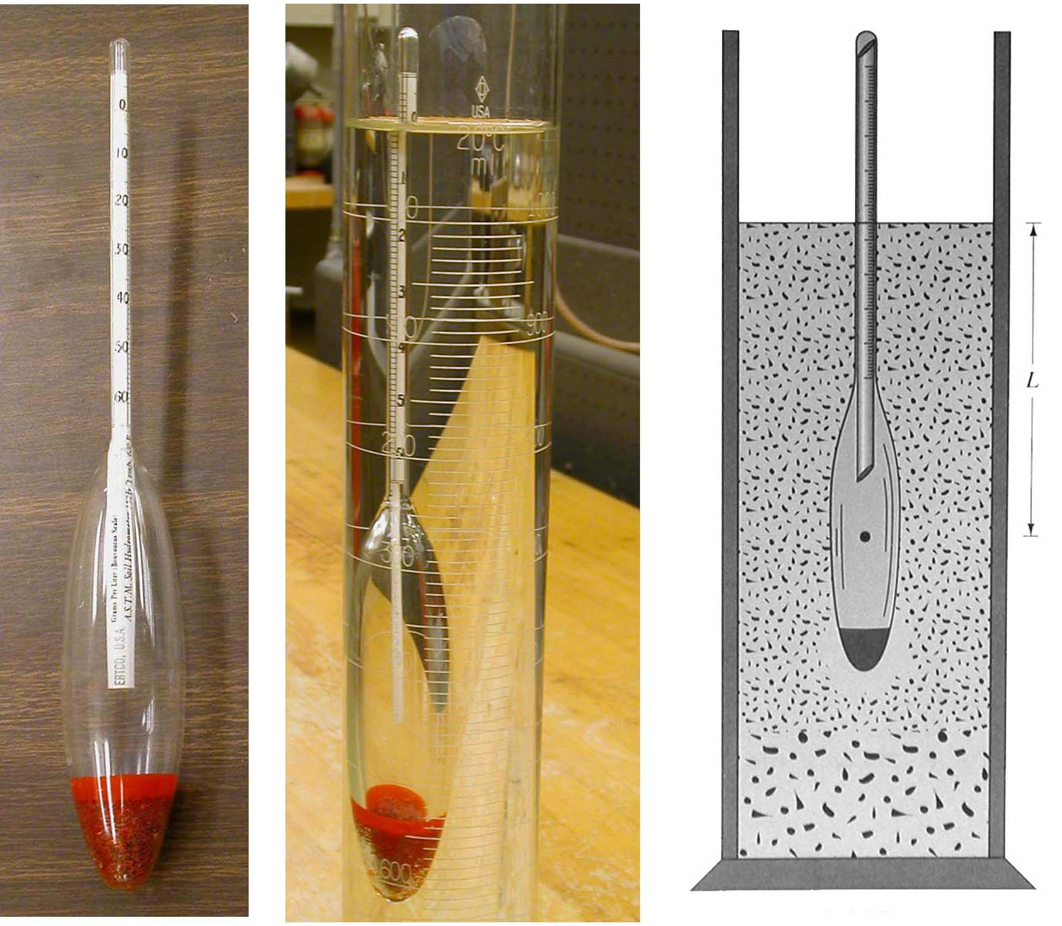
Figure 2b.1: ASTM 152-H hydrometer

Hydrometer reading | L (cm) | Hydrometer reading | L (cm) | Hydrometer reading | L (cm)
0 | 16.29 | 21 | 12.85 | 41 | 9.57
1 | 16.13 | 22 | 12.69 | 42 | 9.41
2 | 15.97 | 23 | 12.52 | 43 | 9.24
3 | 15.80 | 24 | 12.36 | 44 | 9.08
4 | 15.64 | 25 | 12.19 | 45 | 8.91
5 | 15.47 | 26 | 12.03 | 46 | 8.75
6 | 15.31 | 27 | 11.87 | 47 | 8.59
7 | 15.15 | 28 | 11.70 | 48 | 8.42
8 | 14.98 | 29 | 11.54 | 49 | 8.26
9 | 14.82 | 30 | 11.37 | 50 | 8.09
10 | 14.65 | 31 | 11.21 | 51 | 7.93
11 | 14.49 | 32 | 11.05 | 52 | 7.77
12 | 14.33 | 33 | 10.88 | 53 | 7.60
13 | 14.16 | 34 | 10.72 | 54 | 7.44
14 | 14.00 | 35 | 10.55 | 55 | 7.27
15 | 13.83 | 36 | 10.39 | 56 | 7.11
16 | 13.67 | 37 | 10.23 | 57 | 6.95
17 | 13.51 | 38 | 10.06 | 58 | 6.78
18 | 13.34 | 39 | 9.90 | 59 | 6.62
19 | 13.18 | 40 | 9.73 | 60 | 6.45
20 | 13.01
Table 2b.1: Hydrometer reading and L value

The value of K is a function of G_{s} and viscosity of water, which are dependent on the temperature of the test. The table 2b.2 lists the variations of K with G_{s} and the water temperature.

Temperature (ºC) | G_{s}
Temperature (ºC) | 2.45 | 2.50 | 2.55 | 2.60 | 2.65 | 2.70 | 2.75 | 2.80
16 | 0.01510 | 0.01505 | 0.01481 | 0.01457 | 0.01435 | 0.01414 | 0.01394 | 0.01374
17 | 0.01511 | 0.01486 | 0.01462 | 0.01439 | 0.01417 | 0.01396 | 0.01376 | 0.01356
18 | 0.01492 | 0.01467 | 0.01443 | 0.01421 | 0.01399 | 0.01375 | 0.01359 | 0.01339
19 | 0.01474 | 0.01449 | 0.01425 | 0.01403 | 0.01382 | 0.01361 | 0.01342 | 0.01323
20 | 0.01456 | 0.01431 | 0.01408 | 0.01386 | 0.01365 | 0.01344 | 0.01325 | 0.01307
21 | 0.01438 | 0.01414 | 0.01391 | 0.01369 | 0.01348 | 0.01328 | 0.01309 | 0.01291
22 | 0.01421 | 0.01397 | 0.01374 | 0.01353 | 0.01332 | 0.01312 | 0.01294 | 0.01276
23 | 0.01404 | 0.01381 | 0.01358 | 0.01337 | 0.01317 | 0.01297 | 0.01279 | 0.01261
24 | 0.01388 | 0.01365 | 0.01342 | 0.01321 | 0.01301 | 0.01282 | 0.01264 | 0.01246
25 | 0.01372 | 0.01349 | 0.01327 | 0.01306 | 0.01286 | 0.01267 | 0.01249 | 0.01232
26 | 0.01357 | 0.01334 | 0.01312 | 0.01291 | 0.01272 | 0.01253 | 0.01235 | 0.01218
27 | 0.01342 | 0.01319 | 0.01297 | 0.01277 | 0.01258 | 0.01239 | 0.01221 | 0.01204
28 | 0.01327 | 0.01304 | 0.01283 | 0.01264 | 0.01244 | 0.01225 | 0.01208 | 0.01191
29 | 0.01312 | 0.01290 | 0.01269 | 0.01249 | 0.01230 | 0.01212 | 0.01195 | 0.01178
30 | 0.01298 | 0.01276 | 0.01256 | 0.01236 | 0.01217 | 0.01199 | 0.01182 | 0.01169
Table 2b.2: Values of K

In the actual experiment, some corrections to the observed hydrometer readings need to be applied. First one is the temperature correction (F_{T}). The table 2b.3 lists the values of F_{T} for different temperature.

Temperature (ºC) | F_{T} | Temperature (ºC) | F_{T}
15 | -1.10 | 23 | 0.90
16 | -0.85 | 24 | 1.15
17 | -0.60 | 25 | 1.40
18 | -0.35 | 26 | 1.65
19 | -0.10 | 27 | 1.90
20 | 0.15 | 28 | 2.15
21 | 0.40 | 29 | 2.40
22 | 0.65 | 30 | 2.65
Table 2b.3: Values of F_{T}
The other important one is zero correction (F_{Z}).
- ASTM D-422

- Apparatus
  - ASTM 152-H hydrometer
  - Mixer
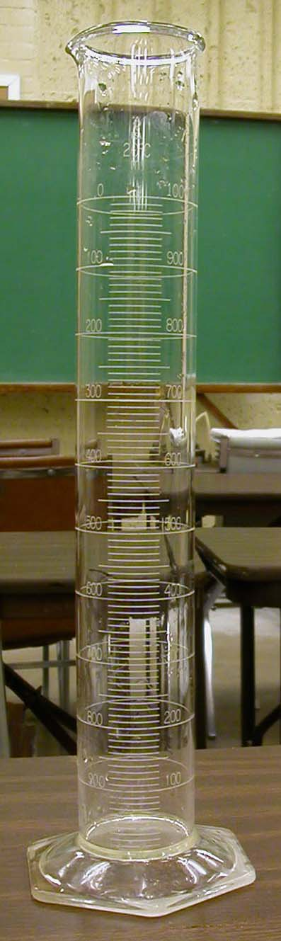
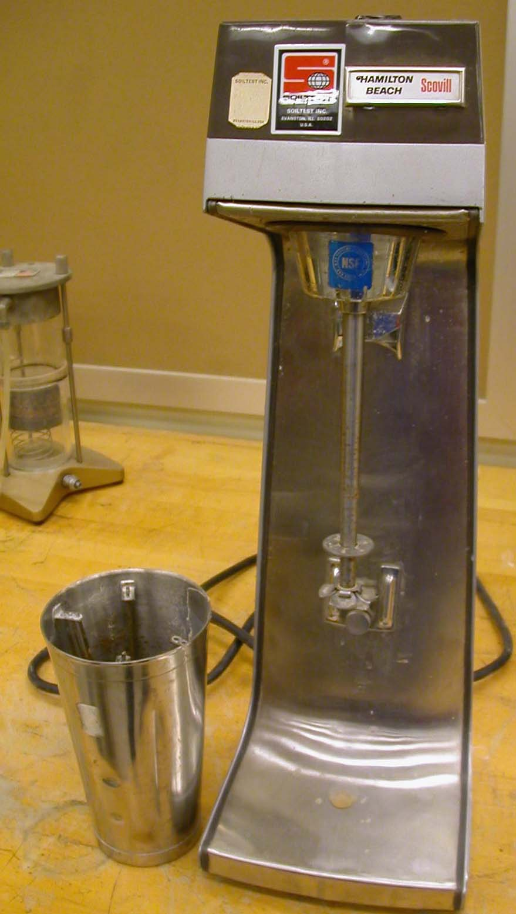
Figure 2b.2: Mixer Figure 2b.3:
Cylinder

  - Two 1000 ml graduated cylinders
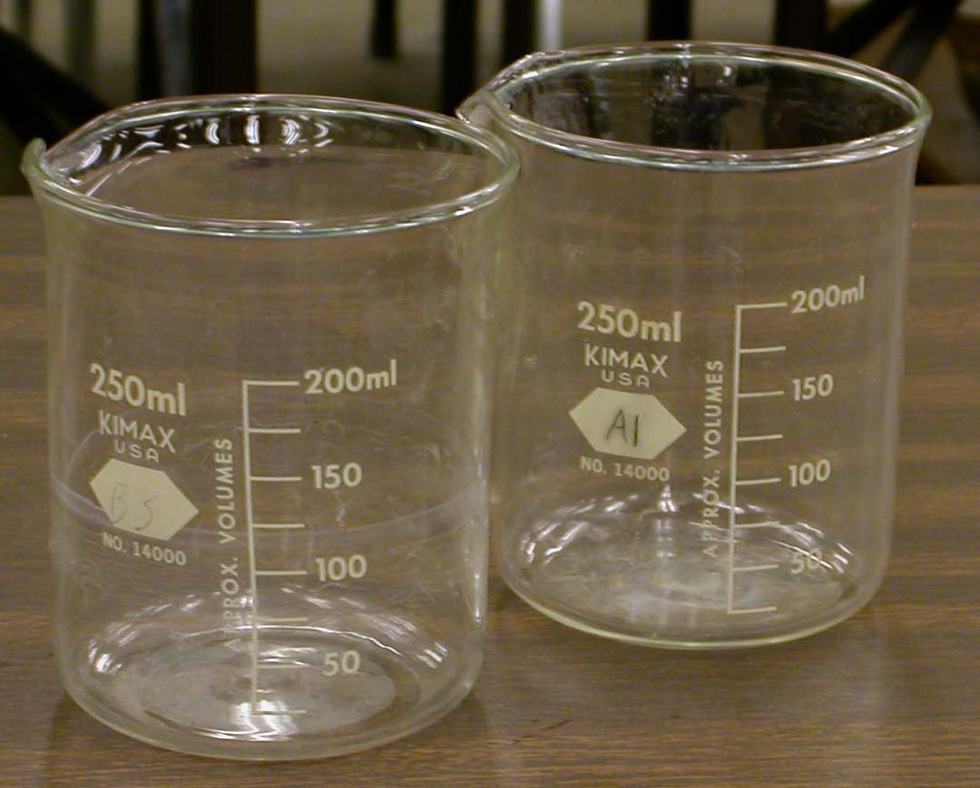
  - Thermometer
  - Deflocculating agent
  - Spatula
  - Beaker
  - Balance
  - Plastic squeeze bottle
  - No. 12 rubber stopper Figure 2b.4: Beaker

- Actual Procedure
  - Take an oven-dry soil sample. Determine its weight (W₁).
  - Pulverize the soil by using a mortar.
  - Run a sieve analysis on the soil sample.
  - Collect the soil that passes through the No. 200 sieve in the bottom pan.
  - Calculate the percent finer for the soil retained on No. 200 sieve and above.
  - Take 50 grams soil sample in the bottom pan.
- Prepare a deflocculating agent: Usually a 4% solution of sodium hexametaphosphate or calgon is used. This can be prepare by adding 40 grams of calgon in 1000 ml water and mixing it thoroughly.
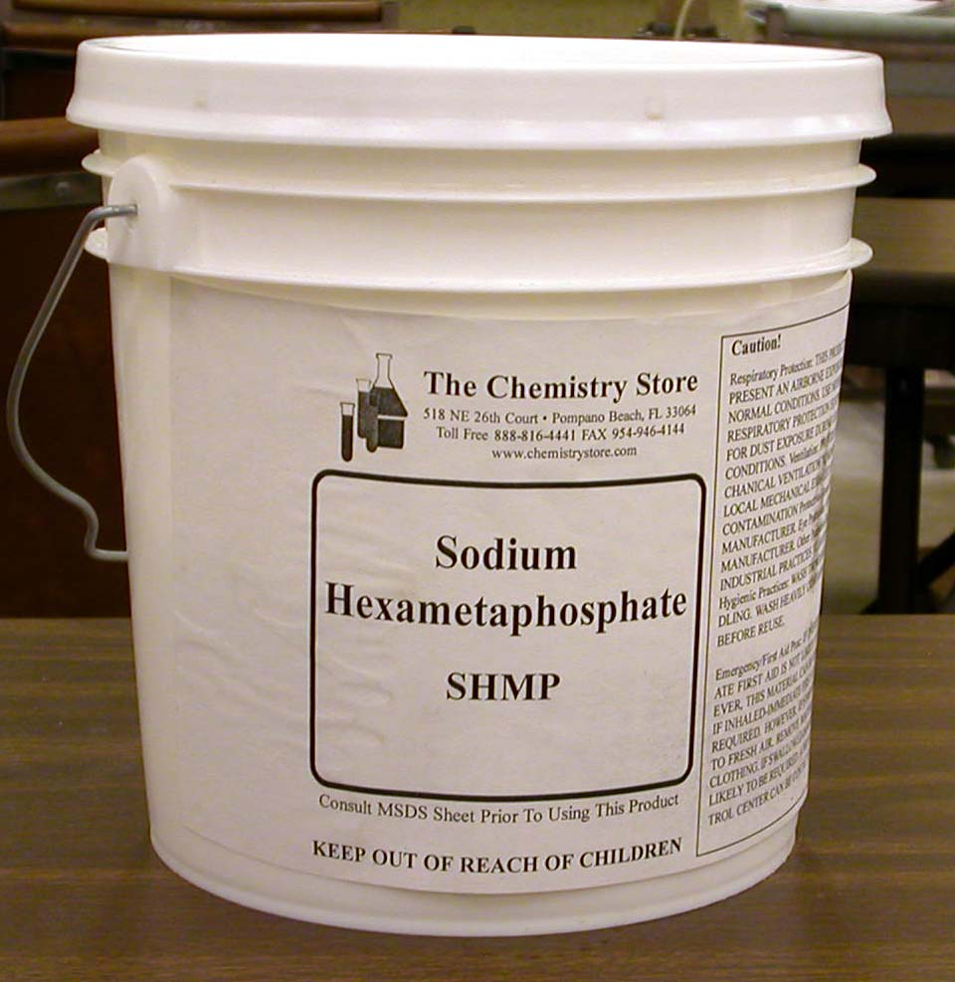
Figure 2b.5: Calgon

- Take 125 ml of the deflocculating agent to add to the soil taken in step 8. Let the soil soak about 12 hours.
- Take the 1000 ml graduated cylinder No. 1 and add 875 ml of water plus 125 ml of deflocculating agent in it. Mix them well.
- Determine the temperature of the solution in the graduated cylinder No. 1 (T _{o}C)
- Put the hydrometer in the cylinder No.1. Record the reading. The top of the meniscus should be read. This reading is the zero correction (F_{Z}).
- Using a spatula thoroughly mix the soil prepared in step 6. Pour it into the mixer cup. Make sure the soil is completely transferred into the mixer cup.
- Add water to the cup to make it about 2/3 full. Mix it for two minutes using the mixer.
- Pour the mix into the 1000 ml graduated cylinder No. 2. Make sure that all of the soil solids are washed out of the mixer cup. Fill the graduated cylinder No. 2 with water to the 1000 ml mark.
- Take hydrometer reading at cumulative times t = 0.25, 0.5, 1, 2, 4, 8, 15, 30, 60, 120, 240, 480, 1440, and 2880 minutes. When taking the reading, insert the hydrometer into the cylinder 30 seconds. After the reading is taken, remove the hydrometer and put it back into the cylinder next to it.

- Calculation and Formula

  - R_{cp}, corrected hydrometer reading for calculating the percent finer, = R + F_{T} - F_{Z}

  - Percent finer = a * R_{cp} * 100 / W
a is the correction for specific gravity. Table 2b.4 lists the values of a.
W is the weight of soil used for the hydrometer analysis.

Gs | a
2.50 | 1.04
2.55 | 1.02
2.60 | 1.01
2.65 | 1.00
2.70 | 0.99
2.75 | 0.98
2.80 | 0.97
Table 2b.4: Values of a

  - Determine the effective length, L, corresponding to the value R given in table 2b.1.

  - Determine K from table 2b.2.

  - Determine D = K * (L / t)^{0.5}

  - Plot a grain size distribution graph on a semi-logarithmic graph paper. The grain size, D, is plotted on the log scale and the percent finer is plotted on the natural scale (figure 2b.6).
- Sample Report

Hydrometer Analysis
Description of soil |  |  |  | Sample No.
Location
G_{s} = |  |  | Hydrometer type
Dry weight of soil, W g |  |  | Dispersing agent ºC
Meniscus correction, F_{m} |  |  | Zero correction, F_{s}
Temperature correction, F_{T}
Tested by |  |  | Date
Time (min) | Hydrometer reading, R | R_{cp} | Percent finer, ((a*R_{cp})/W)*100 | L (cm) | K | D (mm)
0.25
0.5
1
2
4
8
15
30
60
120
240
480
1440
2880

- Sample Graph

Figure 2b.6: Percent finer vs. grain size

