Liquid Limit Test

Introduction
Depending on the moisture content, the behavior of soil can be divided into four basic states. They are solid, semisolid, plastic, and liquid. The moisture content at the point of transition from plastic to liquid state is the liquid limit.
- ASTM D-4318

- Apparatus
  - Casagrande liquid limit device
  - Grooving tool
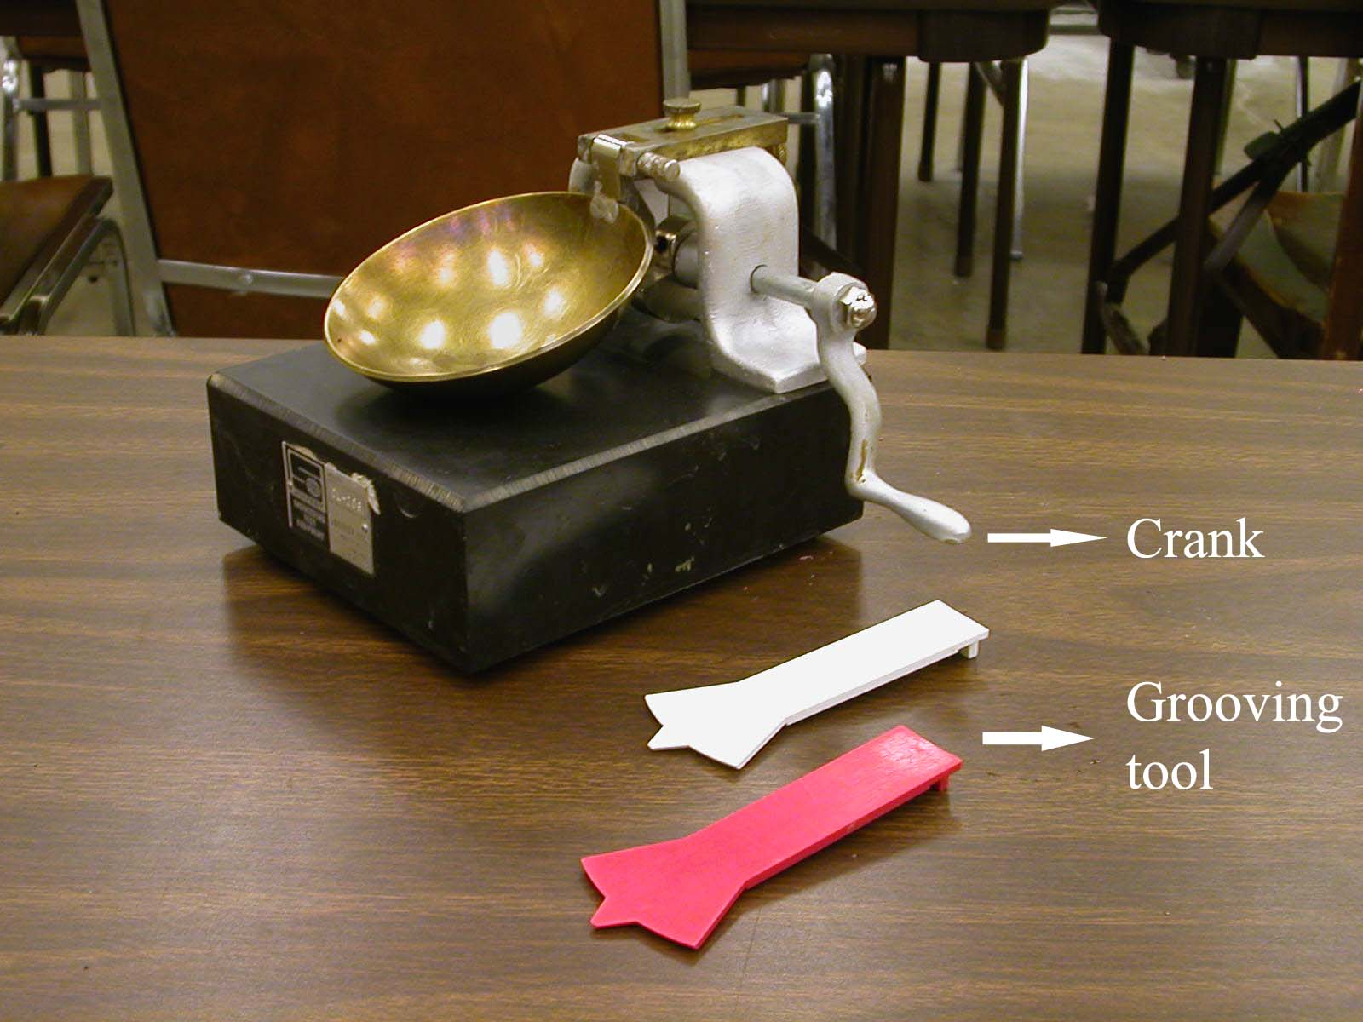
Figure 3.1: Liquid limit device and grooving tools

  - Moisture cans
  - Evaporating dish
  - Spatula
  - Oven
  - Balance
  - Plastic squeeze bottle
  - Paper towels
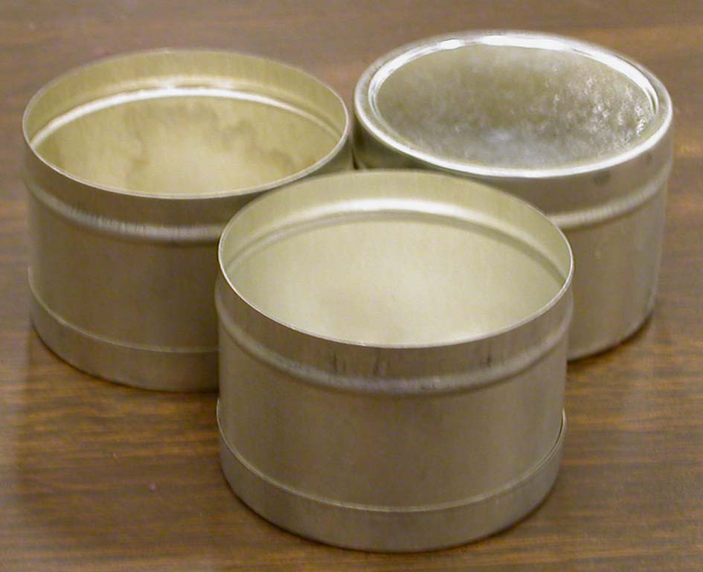

Figure 3.2: Moisture cans
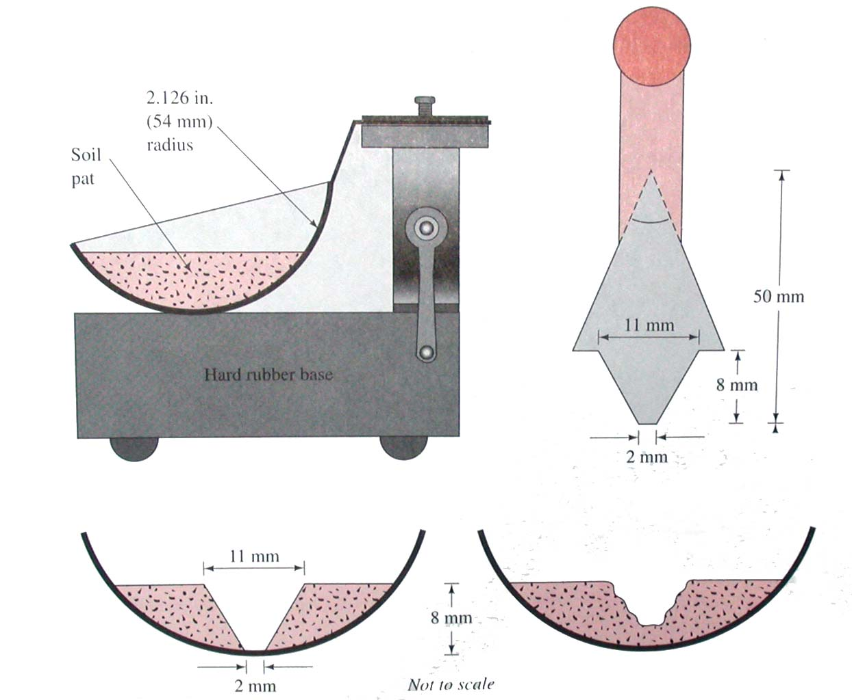

Figure 3.3: The specification of liquid limit device and the grooving
tool

Actual Procedure

  - Determine the each mass of three moisture cans (W₁).
  - Put 250 g of air-dry soil passed through No. 40 sieve into an evaporating dish. Add water and mix the soil to the form of a uniform paste.
  - Place a portion of the paste in the brass cup of the liquid limit device. Using the spatula smooth the surface of the soil in the cup that the maximum depth of the soil is 8 mm.
  - Using the grooving tool cut a groove along the center line of the soil pat in the cup.
  - Turn the crank of the liquid limit device at the rate of 2 revolutions per second. By doing this, the liquid limit cup will rise up and drop through a vertical distance of 10 mm once for each revolution. The soil from two sides of the cup will begin to flow toward the center. Count the number of blows, N, for the groove in the soil to close through a distance of half inch.
  - If N is between 25 and 35, collect a moisture sample from the soil in the cup in a moisture can. Close the cover of the can and determine the mass of the can plus the moist soil (W₂). Then remove the rest of soil paste from the cup to the evaporating dish and clean the cup. If N is higher than 35, add more water in the step 2, then repeat the step 3, 4, and 5.
  - Add more mater to the soil paste in the evaporating dish and mix well. Repeat the step 3, 4, and 5 to get the blow count, N, between 20 and 25. Collect some sample in the moisture can, close the cover, and weigh it. Then remove the soil paste to the evaporating dish and clean the cup.
  - Add more water in the soil paste and mix well in order to get the N between 15 and 20. Collect some soil sample in a moisture can, close the cover, and weigh it.
  - Put the three moisture cans in the oven to dry to constant masses (W₃).

- Calculation and Formula

- Determine the moisture content (w%)for each of the three trials.
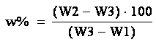

- Plot a semi-log graph (figure 3.4) between moisture content versus number of blow, N (log scale). Try to find the moisture content corresponding to N = 25. This is the liquid limit of the soil.

- Sample Report

Liquid Limit Test
Description of soil |  | Sample No.
Location
Tested by |  | Date
Test No. | 1 | 2 | 3
Can No.
Mass of can, W₁ (g)
Mass of can + moist soil, W₂ (g)
Mass of can + dry soil, W₃ (g)
Moisture content, w (%) = (W₂-W₃)/(W₃-W₁) * 100
Number of blows, N
Liquid limit =

- Sample Graph

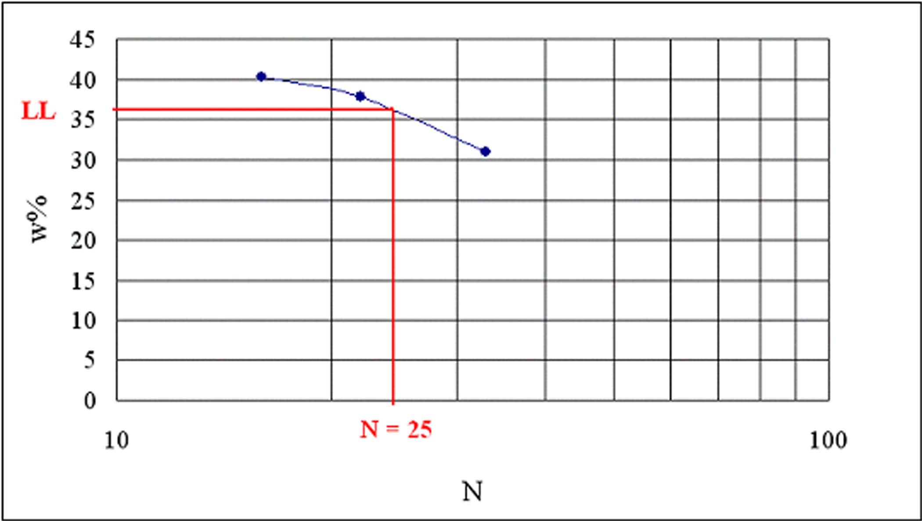 Figure 3.4: Water content vs. number of blow

