Permeability Test in Sand
There are two standard laboratory test procedures for determining the coefficient of permeability of soil: the constant head and the falling head test.
V.a Constant Head

- Introduction
In this type of laboratory setup, the water supply at the inlet is adjusted in such a way that the difference of head between the inlet and the outlet remains constant during the period of test. After a constant rate of flow is established, water is collected in a graduated flask or cylinder for a known duration.
- ASTM D-2434

- Apparatus
- Combination permeameter K-605A
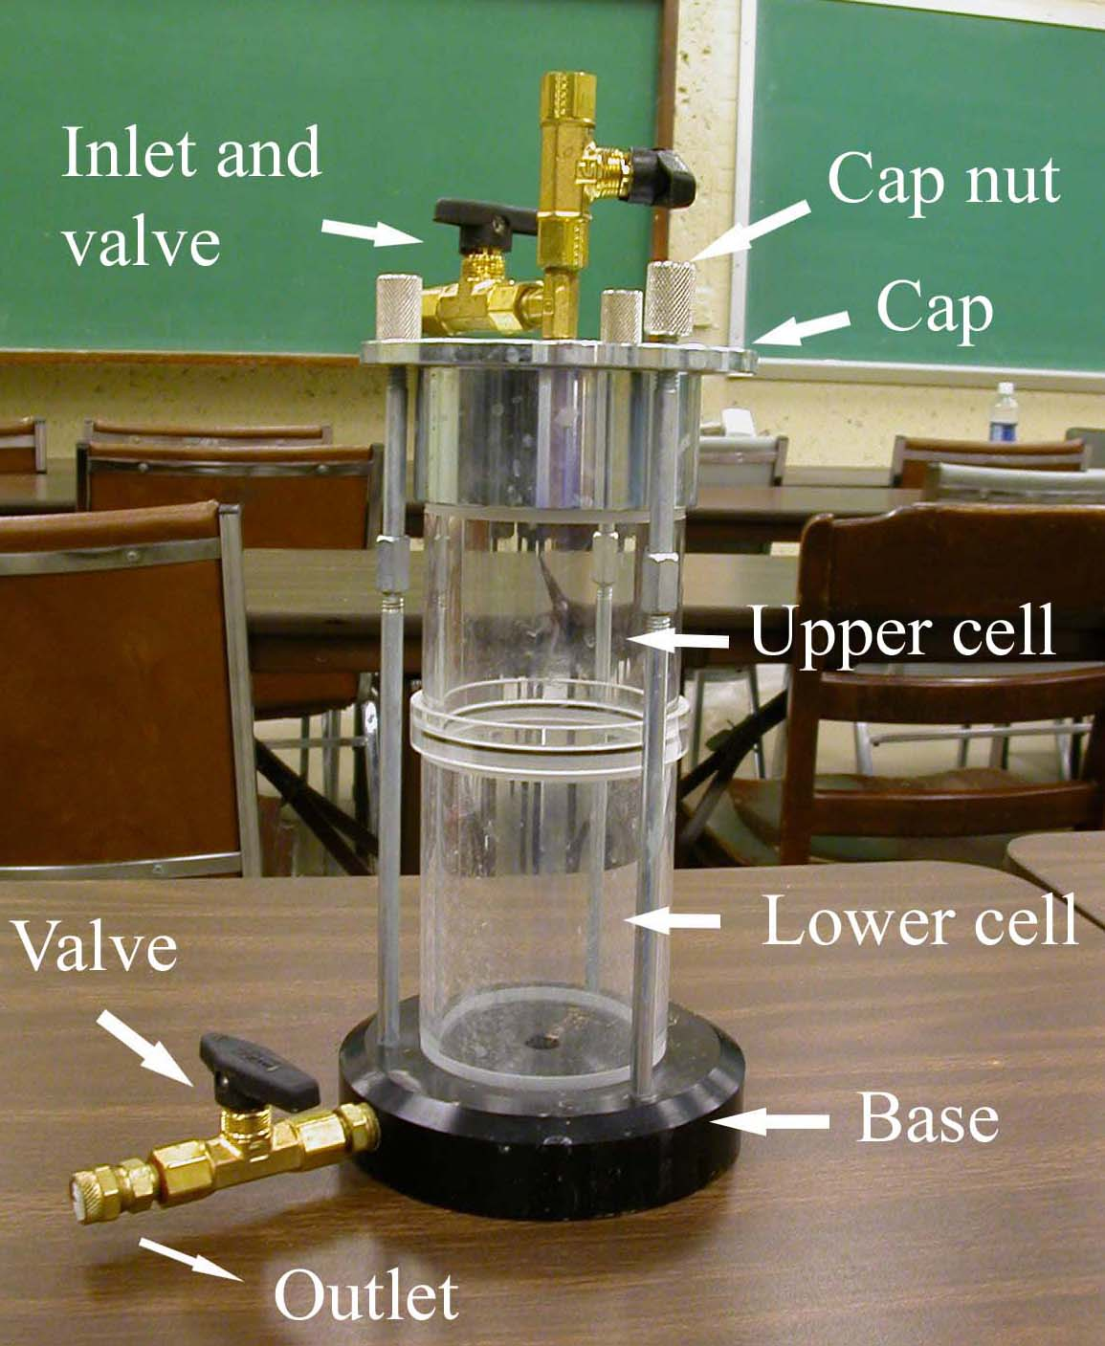
Figure 5a.1: Combination permeameter
K-605A
- Graduated cylinder
- Thermometer
- Porous stone
- Spring
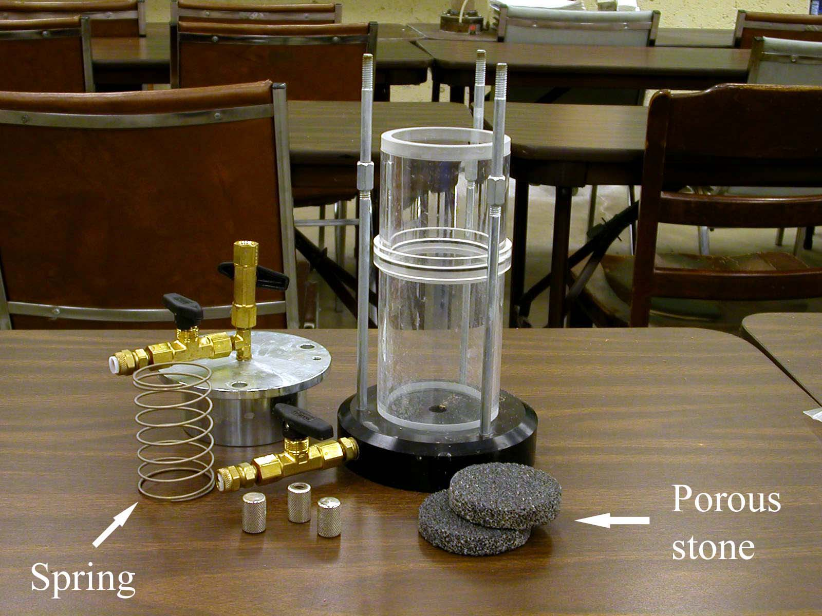
Figure 5a.2: Porous stone and spring

- Rubber tubing
- Stop watch

- Actual Procedure
  - Slip the bottom porous stone into the specimen chamber.
  - Collect oven-dry sand. Pour the sand into the specimen chamber in small layers, and compact it by vibration.
  - After the specimen chamber is filled by sand about 2/3 full, slip the top porous stone into the chamber to rest firmly on the sand.
  - Place a spring on the top porous stone.
  - Close the cap and tighten the cap nuts.
  - Measure the length (L) of the compacted specimen in the cell.
  - Run water into the top of the large funnel through a plastic tube. The water will flow through the specimen. After some time, the water will flow into the sink through the outlet.
  - Adjust the supply of water to the funnel so that the water level in the funnel remains constant and allow the flow to continue for about 10 minutes in order to saturate the specimen.

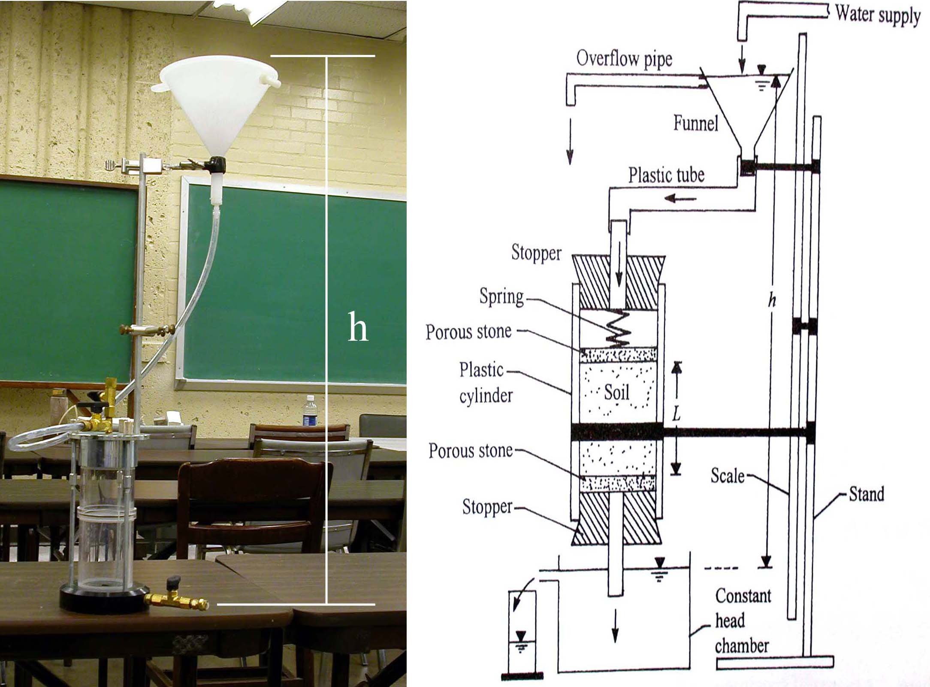
Figure 5a.3: Setup of constant head permeability

  - Remove the air bubbles in the plastic tube.
  - After the steady flow is established, collect the water flowing out of the constant head chamber (Q) in a graduated cylinder. Record the collection time (t) with a stop watch.
  - Repeat step 10 three times. Keep t the same and find Q.
  - Change the head difference, h, and repeat step 9, 10, and 11 three times.
  - Measure the temperature, T, of the water.
- Calculation and Formula

  - Calculate the coefficient of permeability, k.
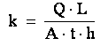

Q is the total volume of water collected
L is the length of the specimen in centimeters.
A is the cross-section of the specimen = 31.65 cm².
t is the duration of collecting water.
h is the hydraulic head difference, or the vertical distance between funnel overflow and the chamber overflow level.

  - Temperature correction of k. The value k is usually given for a test temperature of water at 20 ºC. The table 5a.1 shows the coefficient for different water temperature.
k (at 20ºC) = k (at TºC) * C_{k}

Temperature (TºC) | C_{k} | Temperature (TºC) | C_{k} | Temperature (TºC) | C_{k}
16 | 1.106 | 21 | 0.976 | 26 | 0.869
17 | 1.077 | 22 | 0.953 | 27 | 0.850
18 | 1.051 | 23 | 0.931 | 28 | 0.832
19 | 1.025 | 24 | 0.910 | 29 | 0.814
20 | 1.000 | 25 | 0.889 | 30 | 0.797
Table 5a.1 Coefficient C_{k}

- Sample Report

Constant Head Permeability Test
Test No. | 1 | 2 | 3 | 4 | 5 | 6 | 7 | 8 | 9
Q (cm³)
t (sec)
T(ºC)
h (cm)
A (cm²)
k (cm/s)
Average k
k at 20 ºC

