V.b Falling Head

- Introduction
Water from a standpipe flows through the soil. Initial head difference h₁ at time t = 0 is recorded, and water is allowed to flow through the soil specimen that the final head difference at time t = t_{F} is h₂.

- ASTM D-2434

- Apparatus
- Combination permeameter K-605A
- Thermometer
- Stop watch
- Rubber tubing

- Actual Procedure

- Slip the bottom porous stone into the specimen chamber.
- Collect oven-dry sand. Pour the sand into the specimen chamber in small layers, and compact it by vibration.
- After the specimen chamber is filled by sand about 2/3 full, slip the top porous stone into the chamber to rest firmly on the sand.
- Place a spring on the top porous stone.
- Close the cap and tighten the cap nuts.
- Measure the length (L) of the compacted specimen in the chamber.
- Supply water using a plastic tube from the water inlet to the burette. The water will flow from the burette to the specimen and then to the outlet on the chamber.
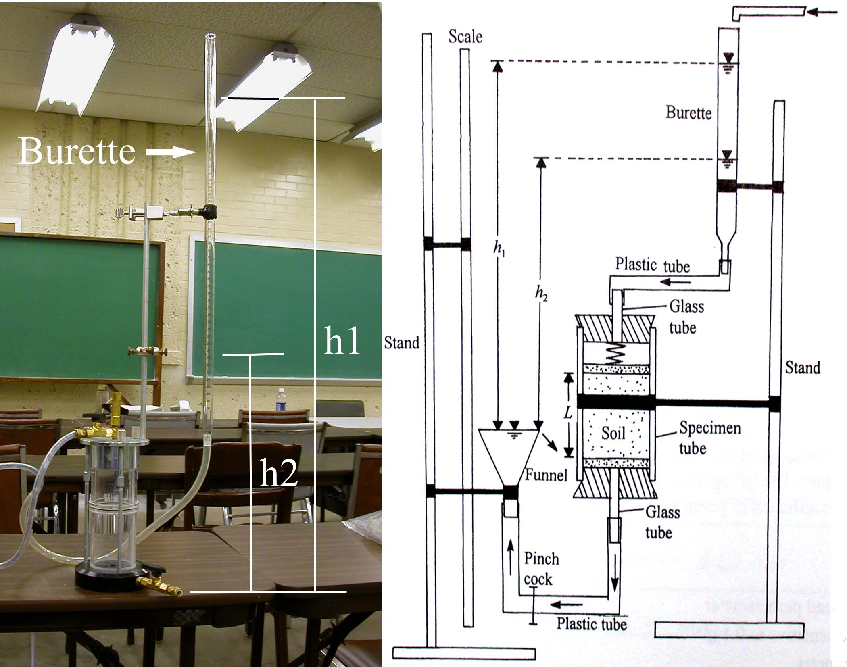
Figure 5b.1: Setup of Falling head permeability

- Remove the air bubbles in the tube.
- Allow the water to flow for some time in order to saturate the specimen.
- Close the outlet valve.
- Measure the head difference, h₁, which is the vertical distance between the water level in the burette and the level of outlet.
- Open the valve. Water will flow through the burette to the specimen and then out of outlet. Record time (t) with a stop watch until the head difference is equal h₂, which is the vertical distance between new water level and the level of outlet. Then close the valve.
- Determine the volume, V, of water that is drained from the burette in cm³.
- Add more water to the burette to make another run and change h₁ and h₂ all the time.
- Record the temperature, T (ºC), of the water.

- Calculation and Formula

  - The coefficient of permeability k
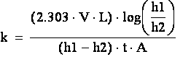

L is the length of the specimen.
A is the cross-section of the specimen.

  - Temperature correction of k. The value k is usually given for a test temperature of water at 20 ºC. The table 5a.1 shows the coefficient for different water temperature.
k (at 20ºC) = k (at TºC) * C_{k}

Temperature (TºC) | C_{k} | Temperature (TºC) | C_{k} | Temperature (TºC) | C_{k}
16 | 1.106 | 21 | 0.976 | 26 | 0.869
17 | 1.077 | 22 | 0.953 | 27 | 0.850
18 | 1.051 | 23 | 0.931 | 28 | 0.832
19 | 1.025 | 24 | 0.910 | 29 | 0.814
20 | 1.000 | 25 | 0.889 | 30 | 0.797
Table 5b.1 Coefficient C_{k}

- Sample Report

Falling Head Permeability Test
Test No. | 1 | 2 | 3 | 4 | 5 | 6 | 7 | 8 | 9
L (cm)
A (cm²)
h₁ (cm)
h₂ (cm)
t (sec)
T(ºC)
k (cm/s)
Average k
k at 20 ºC

