Direct Shear Test on Sand

- Introduction

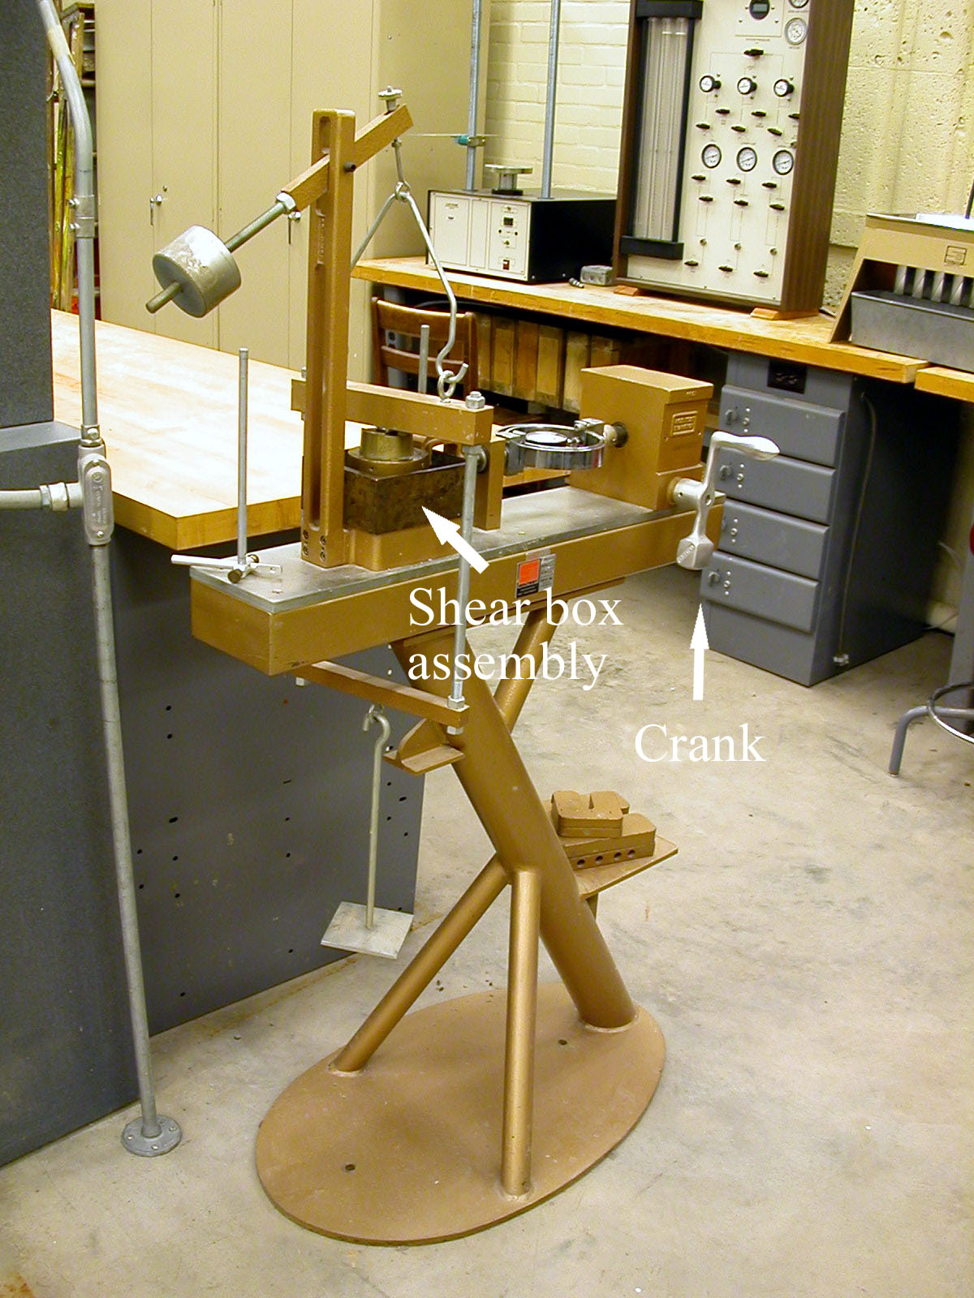
This is the oldest and simplest form of shear test arrangement. The test equipment consists of a metal shear box where the soil specimen is placed. The soil specimen is circular in plan. The box is split horizontally into halves. Normal force on the specimen is applied from the top of the shear box. The shear force is applied by moving one half of the box relative to the other to cause failure in the soil specimen.

Figure 6.1: Direct shear test machine

Depending on the equipment, the shear test can be either stress-controlled or strain-controlled. The equipment in our laboratory is a strain-controlled one.
In strain-controlled tests, a constant rate of shear displacement is applied to one half of the box. The resisting shear force of the soil corresponding to any shear displacement can be measured by a horizontal proving ring or load cell.
- ASTM D-3080

- Apparatus
  - Direct shear test machine
  - Shear box assembly
  - Balance

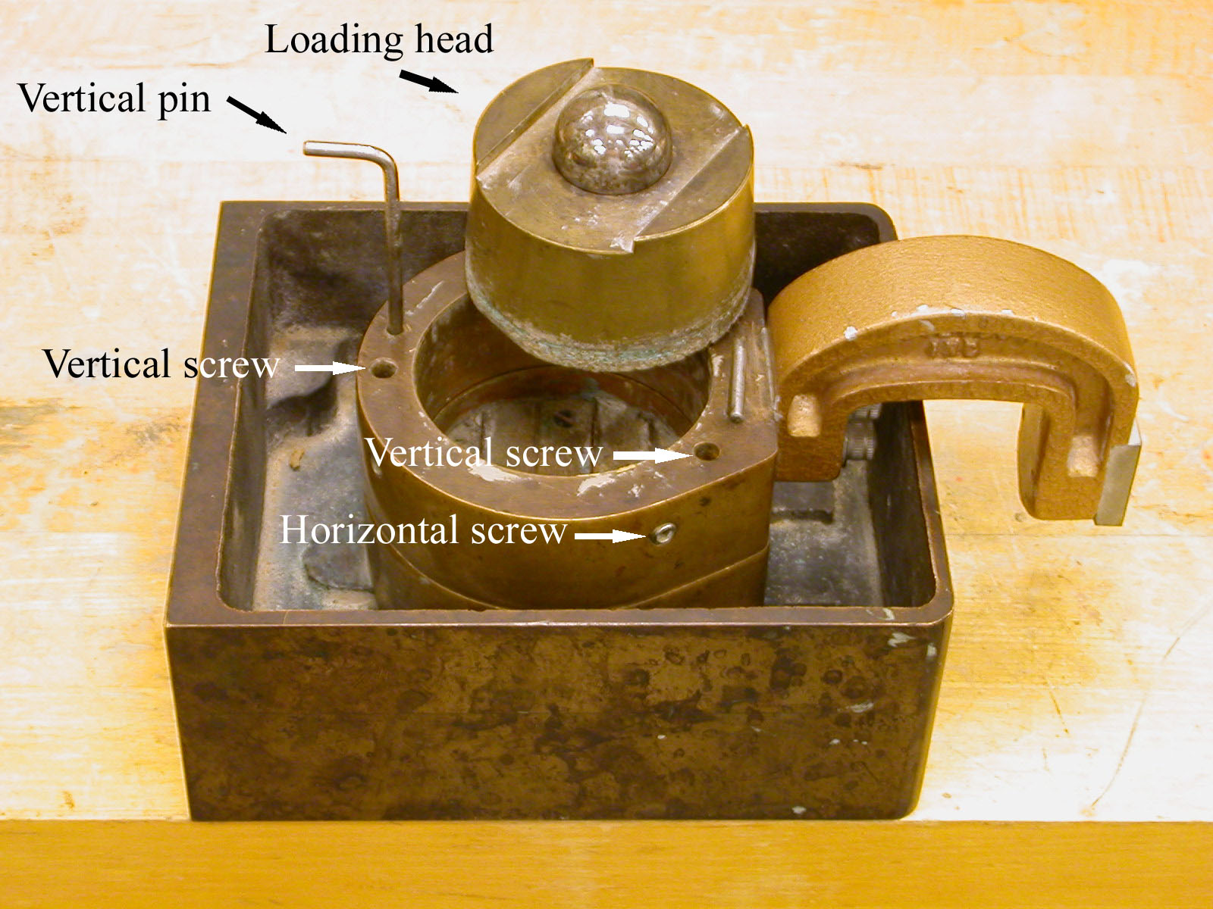
Figure 6.2: Shear box assembly

- Actual Procedure

  - Remove the shear box assembly from test machine. Remove the loading head. Insert the two vertical pins to keep the two halves of the shear box together.
  - Fill the shear box with dry sand in small layers. The top of the compacted specimen should be 1/4 inch below the top of the shear box. Level the surface of the sand specimen.
  - Determine the dimensions of the soil specimen.
  - Slip the loading head down from the top of the shear box to rest on the soil specimen.
  - Place the shear box assembly in the direct shear machine.
  - Apply the desired normal load, N, on the specimen. This can be done by hanging dead weights to the vertical load yoke. The top crossbars will rest on the loading head of the specimen.
  - Remove the two vertical pins.
  - Advance the three vertical screws on the side walls of the top half of the shear box. This is done to separate the two halves of the box. The space between the two halves of the box should be slightly large than the largest grain size of the specimen.
  - Set the loading head by tightening the two horizontal screws on the top half of the shear box. Back off the three vertical screws. After doing this, there will be no connection between the two halves of the shear box except the soil.
  - Apply horizontal load, S, to the top half of the shear box by turning the crank. Turn the crank at the rate of 1 revolution per second.
  - Record the maximum proving ring gauge reading.
  - Repeat steps 1 to 11 at least two more times.
  - Repeat the test with another two different normal loads, N.
- Calculation and Formula

  - Calculate the normal stress, σ (lb/in.²), on the specimen

σ = N / A

N (lb) is normal load
A (in.²) is the cross-section area of the specimen

  - Calculate the shear force, S (lb)

S = (0.3119151591 * Y) + 2.0222499482

Y is the number of divisions in proving ring dial gauge

  - Calculate the shear stress, τ (lb/in.²)

τ = S / A

  - Plot a graph of shear stress, τ, vs. normal stress σ (Figure 6.3).
  - Calculate the angle of friction of the soil, φ

φ = tan⁻¹ (τ / σ)

- Sample Report

Direct Shear Test on Sand
Description of soil ___________________________________________
Location ___________________________________________________
Test by _______________________ Date ________________________
Normal Load, N | Normal stress, σ | No. of div. In proving ring dial gauge | Shear force, S | Shear stress, τ

- Sample Graph

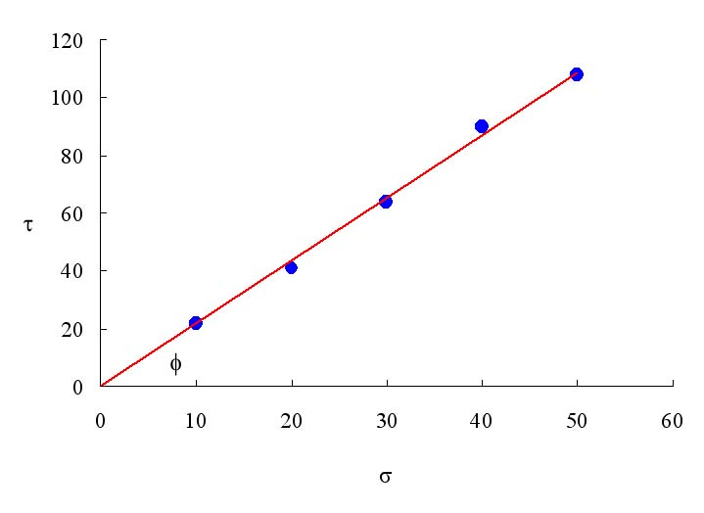
Figure 6.3: τ vs. σ

