Unconfined Compression Test

- Introduction
This is a special type of unconsolidated-undrained test that is commonly used for clay specimens. In the test, the confining pressure σ3 is zero. An axial load is rapidly applied to the specimen to cause failure. At failure the total minor principal stress is zero and the total major principal stress is σ1.

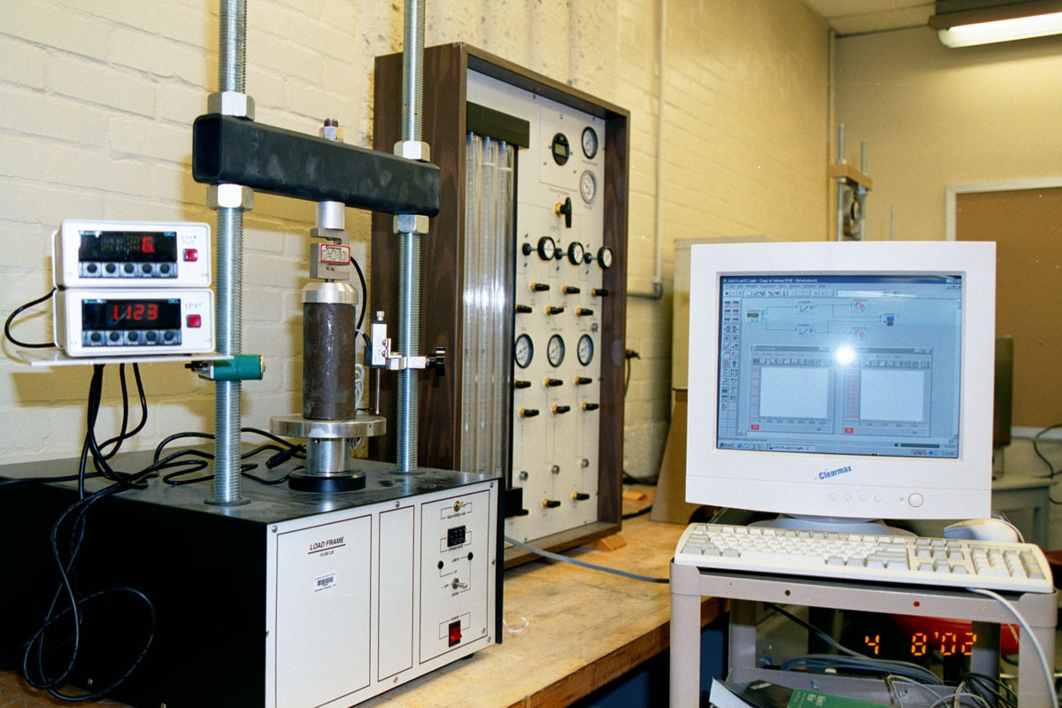
Figure 7.1: Unconfined compression test

- ASTM D-2166

- Apparatus
  - Load cell with digital readout
  - LVDT with digital readout
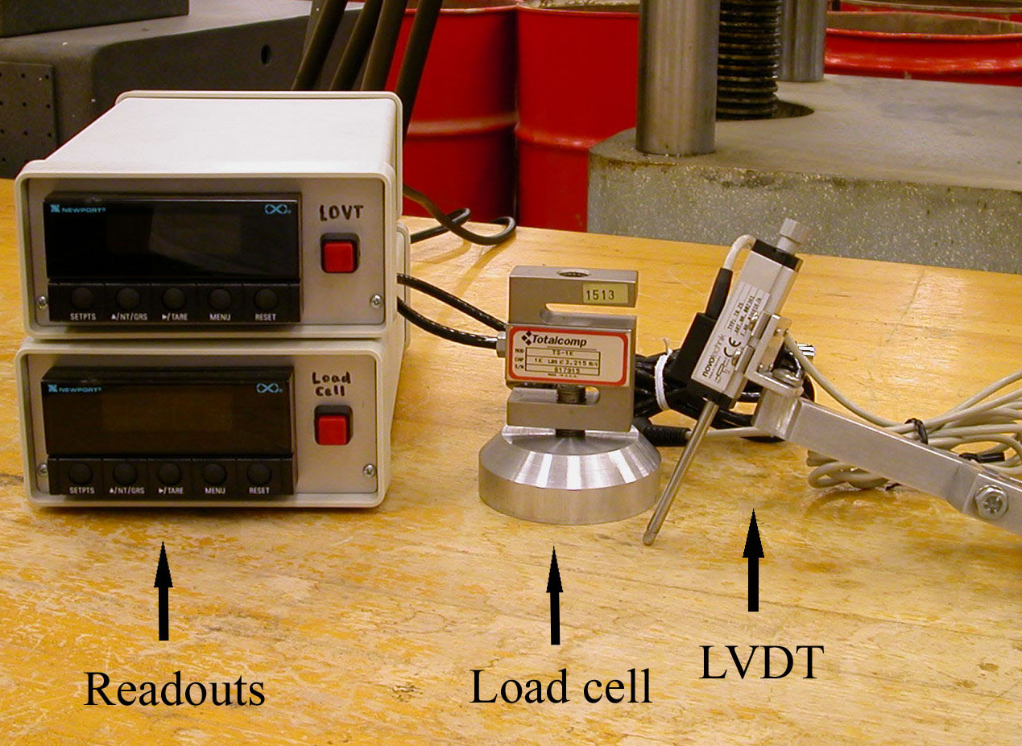
Figure 7.2: Load cell, LVDT, and readouts

  - Load frame
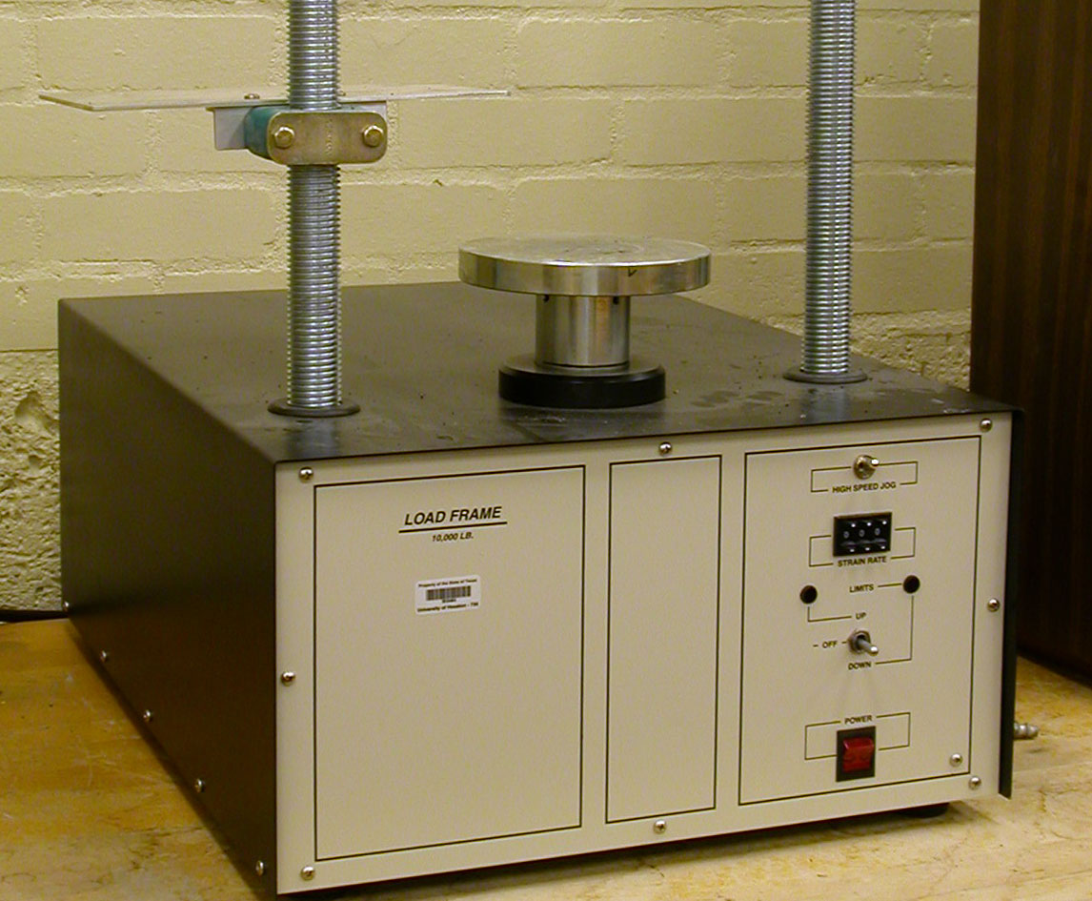
Figure 7.3: Load frame

  - Computer with data acquisition system
  - Balance

- Actual Procedure

  - Connect the load cell, LVDT, and the two digital readouts to the data acquisition system.
  - Turn on the computer and let the program be ready.
  - Measure the diameter (D) and length (L) of the specimen and weigh the specimen.
  - Place the specimen centrally between the two loading plates of the unconfined compression test machine. Move the top loading plate very carefully just touch the top of the specimen.
  - Zero out the LVDT and the load cell readouts.
(Note: Refer to Appendix.A)
  - Start and record the test.
  - Stop test right after the load reaches a peak and then decreases or the load reaches a maximum value and remains approximately constant.

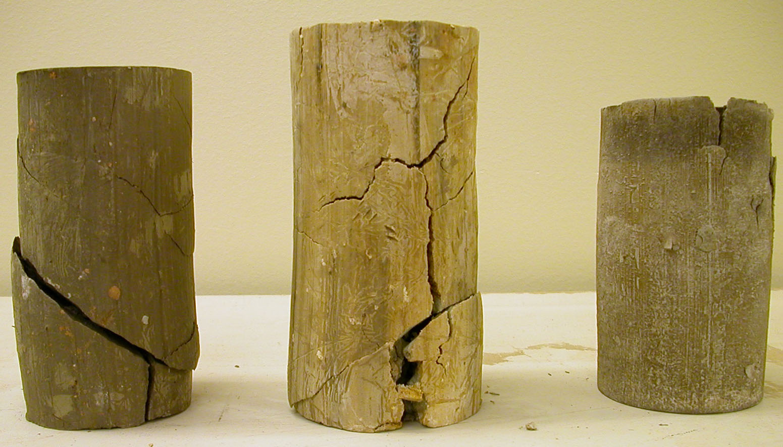
Figure 7.4: Failure of specimens

  - Save the data file with the ASCII format to the Microsoft Excel file.

- Calculation and Formula

- Calculate the shear strain, ε (%)

ε = ΔL / L

ΔL is the specimen deformation or the reading of the LDVT

- Plot the graph of shear stress, σ, vs. shear strain, ε

- Sample Report

Unconfined Compression Test
Description of soil _________________________________________________
Location _________________________________________________________
Mass of specimen ______________g Length of specimen, L ______________in.
Diameter of specimen, D ________in. Area, A = πD² / 4 = _______________in.
Tested by _____________________________ |  |  | Date _____________________
Time | Load force (lb) | Shear stress, σ (lb/in.²) | Specimen deformation = ΔL (in.) | Vertical strain ε = ΔL / L (%)
- Sample graph

Figure 7.4: Shear stress vs. Shear strain
