Consolidation Test

- Introduction
Consolidation is the process of time-dependent settlement of saturated clayey soil when subjected to an increased loading. The one-dimensional consolidation method will be chosen in our laboratory. The test is performed in a consolidometer. The soil specimen is placed inside a metal ring with two porous stones, one at the top of the specimen and another at the bottom. The specimen is usually 2.5 inches in diameter and 1 inch thick. The load on the specimen is applied through a lever arm, and compression is measured by a strain gauge. The specimen is kept under water during the test. Each load is usually kept for 24 hours but we don’t have that long time for that in our laboratory. So we just wait until no more deformation of specimen happens. After that, the load is usually doubled and the compression measurement is continued.

- ASTM D-2435
- Apparatus
  - Consolidation test unit
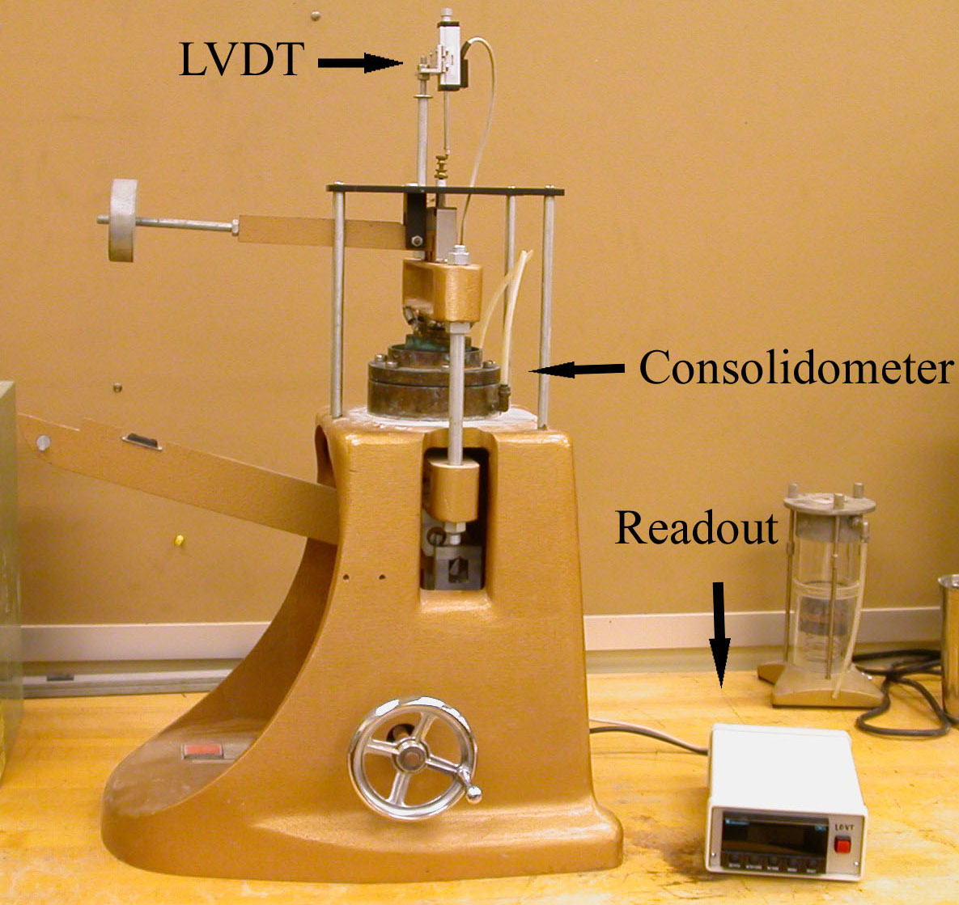
Figure 9.1: Consolidation test unit
  - Consolidometer
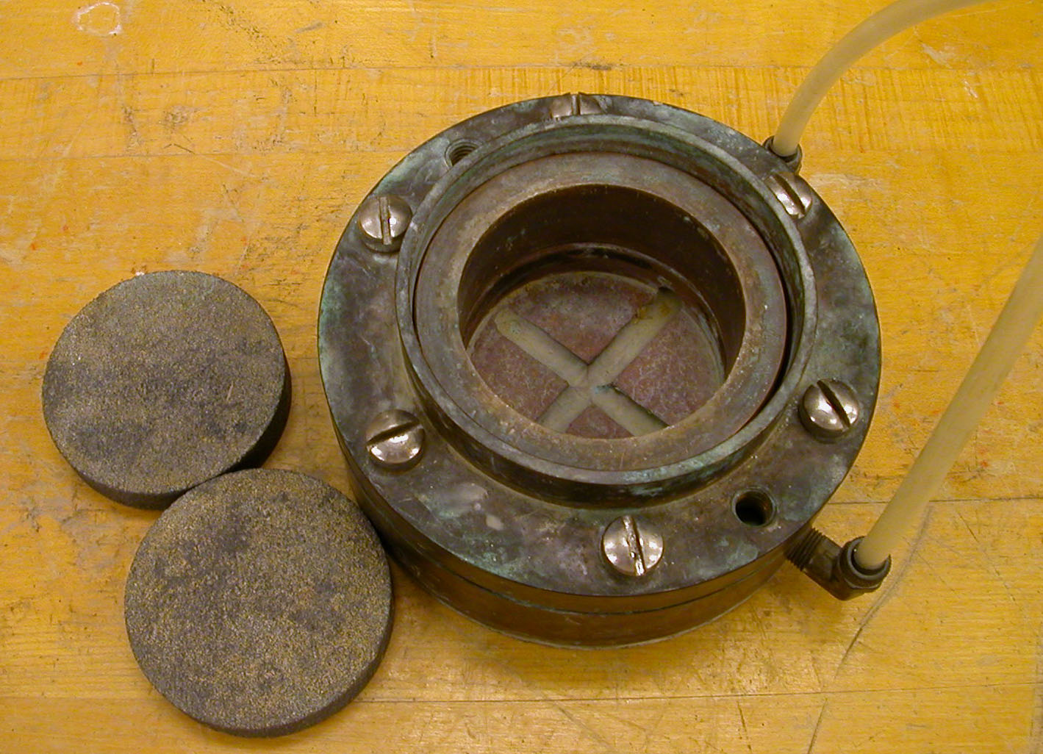
Figure 8.2: Consolidometer with porous stones

  - LDVT with digital readout
  - Computer with data acquisition system
  - Trimming device
  - Balance
  - Moisture can
  - Oven
- Actual Procedure

  - Use the trimming device to prepare the soil specimen. The soil specimen should be 2.5 inches in diameter and 1 inch thick.
  - Determine the moisture content and specific gravity of soil solids, G_{s}, from some excess soil that has been trimmed.
  - Determine the mass of the consolidation ring (W₁) in grams.
  - Determine the mass of the consolidation ring and the specimen (W₂) in grams.
  - Place the lower porous stone on the base of the consolidometer and saturate it.
  - Place the soil specimen in the ring over the lower porous stone.
  - Place the upper porous stone on the specimen in the ring.
  - Attach the loading head to the consolidometer.
  - Add water to the consolidometer to submerge the soil and keep it saturated. The outside ring and the stand pipe connection attached to the base should be kept full with water.
  - Place the consolidometer in the loading device.
  - Attach the strain gauge to measure the deformation of specimen.
  - Connect the strain gauge to LDVT and connect LDVT to the computer. Zero out the LDVT.
  - Apply load to the specimen such that the magnitude of pressure, p, on the specimen is 0.5 ton/ft² and start the computer program to record the deformation of the specimen.
  - After the specimen does not deform any more, stop the program recording and save the data file in proper name.
  - Add more load to the specimen such that the total magnitude of pressure on the specimen becomes 1 ton/ft². Then start the program to record the deformation of the specimen and stop recording after no deformation of soil happens.
  - Repeat steps 15 for soil pressure magnitudes of 2 ton/ft², 4 ton/ft², and 8 ton/ft².
  - At the end of the test, remove the soil specimen and determine the moisture content.

- Calculation and Formula

  - Plot the graph of strain gauge reading vs. (time)^{0.5}
  - Determine the time for 90% primary consolidation, t₉₀, from each set of time vs. strain gauge readings by using the square-root-of-time fitting method.
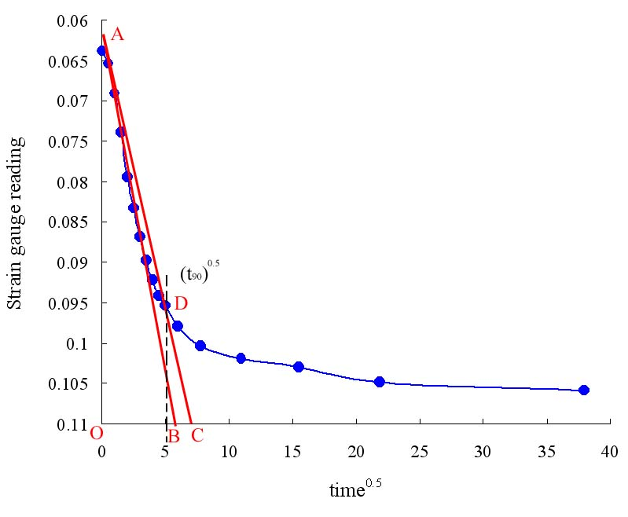
Figure 8.3: The square-root-of-time fitting method

The square-root-of-time fitting method:
  - Draw a line AB through the early portion of the curve.
  - Draw a line such that OC = 1.5OB. The abscissa of point D, which is the intersection of AC and the consolidation curve, gives the square root of time for 90% consolidation.

    - Determine the Height of solids (H_{S}) of the specimen.

H_{S} = W_{S} / (A * G_{S} * ρ_{W})

W_{S} is the dry mass of soil specimen = W₂ – W₁.
A is the cross-section area of the specimen.
G_{S} is the specific gravity of soil solids.
ρ_{W} is the density of water.

    - Determine the change in height, ΔH, of the specimen due to load increments from p to p + Δp.
    - Determine the final specimen height, H_{t(f)}, at the end of consolidation due to a given load.
    - Determine the height of voids, H_{v}, in the specimen at the end of consolidation due to a given load, p.

H_{v} = H_{t(f)} - H_{S}

    - Determine the final void ratio, e, at the end of consolidation for each loading, p.

e = H_{v} / H_{S}

    - Determine the average specimen height, H_{t(av)}, during consolidation for each incremental loading.
    - Calculate the coefficient of consolidation, C_{v}, from t₉₀.

C_{v} = 0.848 * H²_{t(av)} / 4t₉₀

    - Plot semi-logarithmic graphs of pressure vs. final void ratio and pressure vs. C_{v}. Pressure is plotted on the log scale and the final void ratio, e, and the coefficient of consolidation, C_{v}, on the natural scale.

- Sample Report

Consolidation Test
Time vs. Strain Gauge Reading
Description of soil
Location
Tested by |  |  |  | Date
Pressure on specimen lb/ft² |  |  |  | Pressure on specimen lb/ft²
Time after load application, t (min.) | t^{0.5} (min.)^{0.5} | Strain gauge reading (in.) |  | Time after load application, t (min.) | t^{0.5} (min.)^{0.5} | Strain gauge reading (in.)

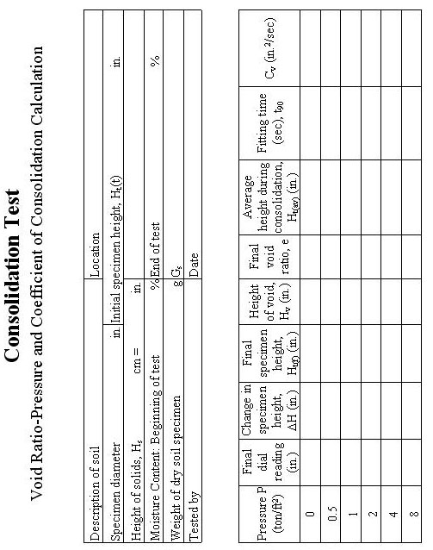

Sample graph

Figure 8.: Void ratio vs. pressure

Figure 8.: C_{v} vs. pressure

