Appendix A. Special Equipments

- Load Frame
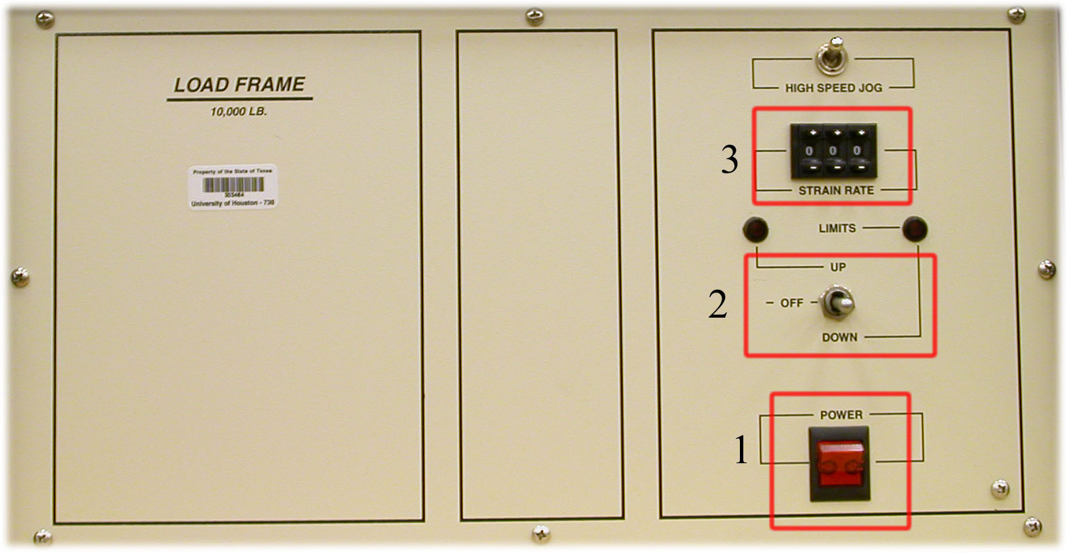
Figure A.1: Load frame

  - Main power On/Off switch: Located at the bottom of the panel, the switch has an indicator light to show when power is on.
  - Platen direction control: A three position switch is used to control the platen direction (up, down, and off)
  - Strain rate control: Strain rates are selected on the three segment, push button digital selector. Table A.1 shows the thumbwheel settings corresponding with the specific strain rate.

Thumbwheel Setting | Strain Rate (in./min) | Thumbwheel Setting | Strain Rate (in./min)
22 | 0.005 | 400 | 0.055
60 | 0.010 | 437 | 0.060
98 | 0.015 | 475 | 0.065
135 | 0.020 | 513 | 0.070
173 | 0.025 | 550 | 0.075
211 | 0.030 | 588 | 0.080
249 | 0.035 | 626 | 0.085
286 | 0.040 | 664 | 0.090
324 | 0.045 | 701 | 0.095
362 | 0.050 | 739 | 0.100
Table A.1: Thumbwheel setting with strain rate
- Load Cell, and LVDT Digital Readout
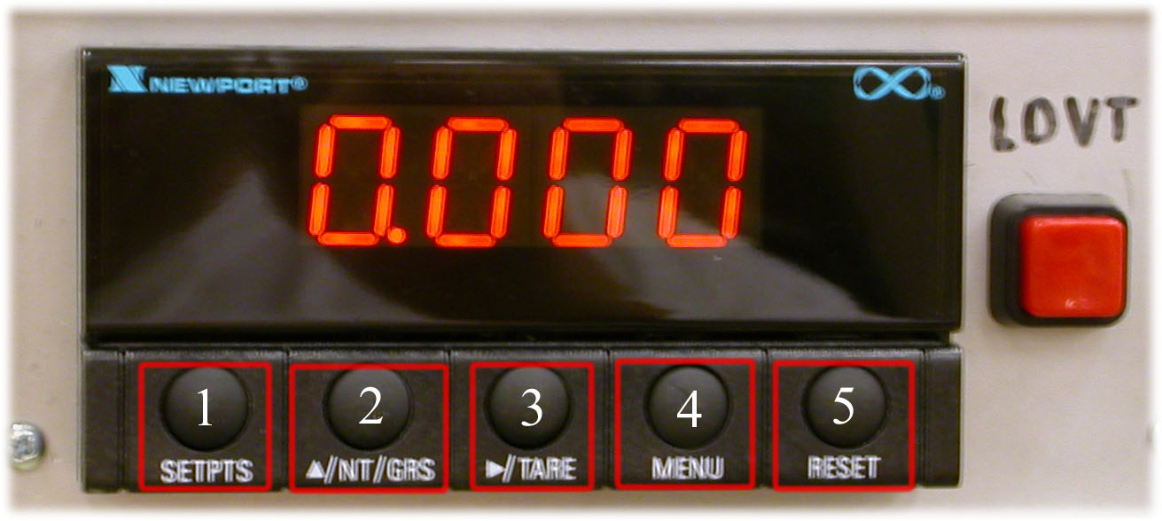
Figure A.2: Digital readout

  - SETPTS button: In the run mode, this bottom will sequentially recall the previous setpoint settings.
  - /NT/GRS button: In the run mode, this bottom will toggle between net/gross readings or peak readings, depending upon your setup.
  - /TARE button: In the run mode press the /TARE button to zero out the reading.
  - MENU button: In the run mode, press the MENU button to terminate the current measuring process and enter you into the configuration mode.
In the configuration mode, press the MENU button to store changes in the nonvolatile memory and the advance you to the next menu item.
  - RESET button: In the run mode, press the RESET button to reset the latched setpoints. The meter shows “SP.RS” and returns to the run mode.
In the configuration mode, press the RESET button to reset the tare value. The meter shows “T.RS”.
In the tare mode, press the RESET button once to review the previous menu. Press the RESET button twice to result in a hard reset and return to the run mode.
- Triaxial Logic Panel
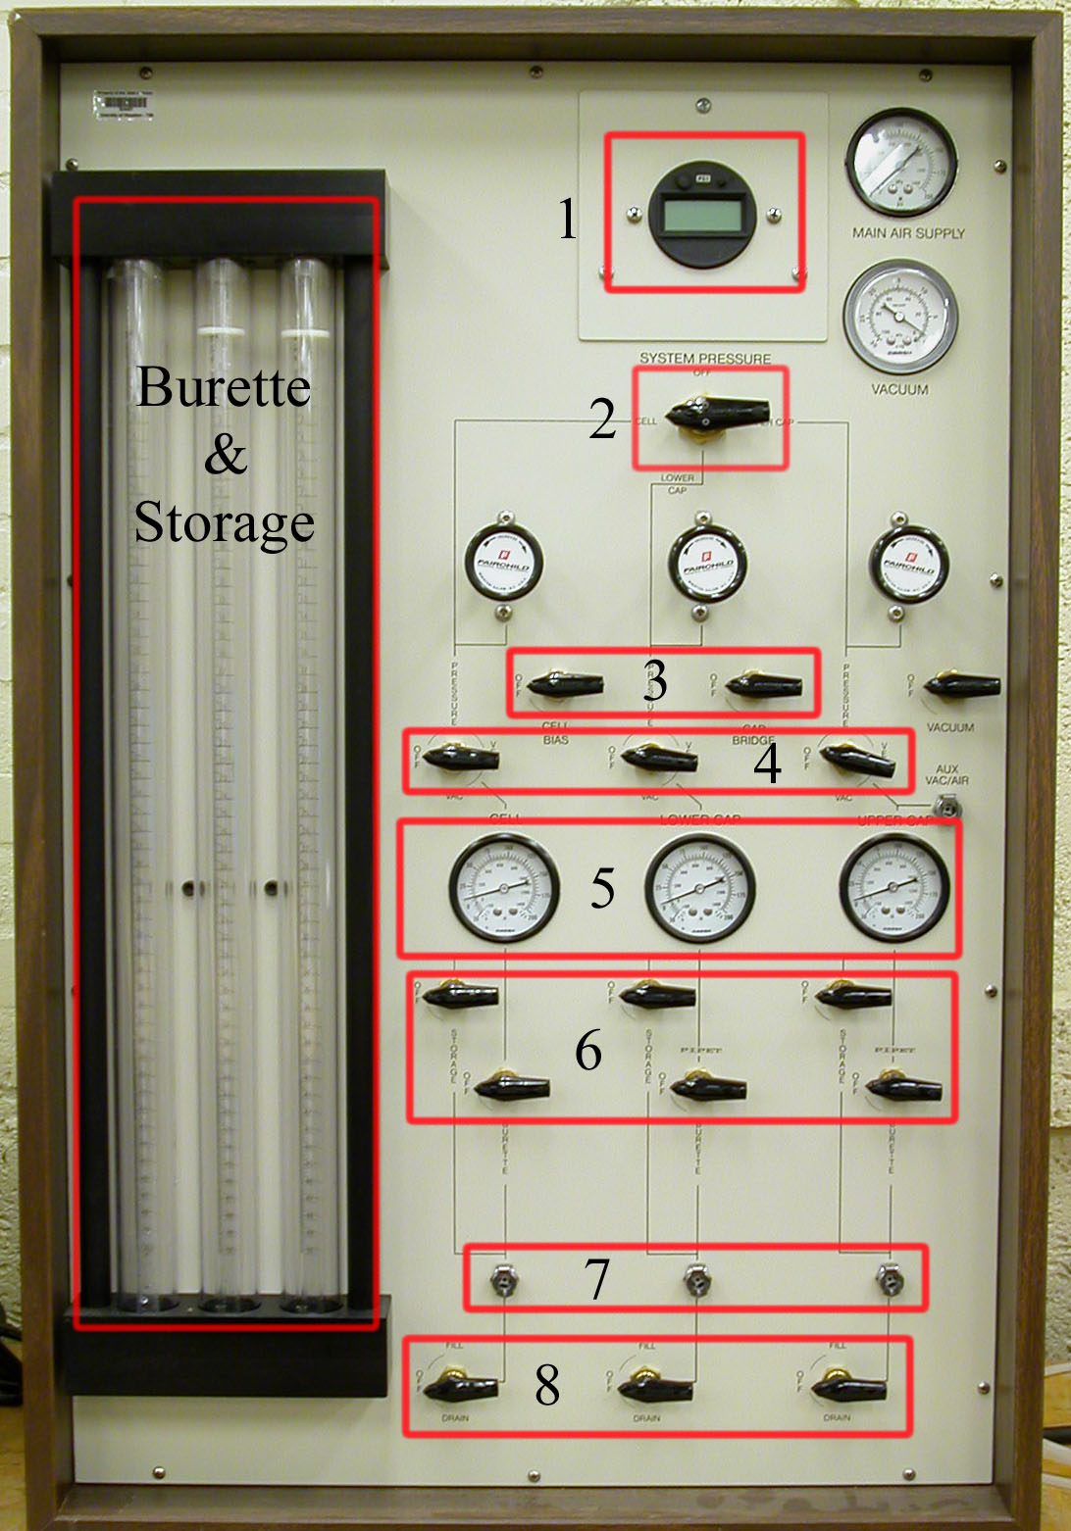
Figure A.: Logic panel

- System pressure digital readout: This readout is used to monitor the pressure of the cell, lower cap, and upper cap storage/burette chambers.
- System pressure selection valve: This valve has four positions. The “OFF” position vents to atmosphere for zeroing the digital readout. The “CELL”, “LOWER CAP”, and “UPPER CAP” positions are used to monitor the pressures from individual pressure regulators.
- Air system control valves: There re two air system control valves, the CELL/CELL BIAS control valve and the CAP BRIDGE control valve. The CELL/CELL BIAS control valve has two positions, OFF and CELL BIAS. The OFF position is used when independent regulation of cell pressure is required. The CELL BIAS position is used to set and maintain the bias pressure when using the lower cap regulator to simultaneously increase the cell and cap pressure.
The CAP BRIDGE control valve has two positions, OFF, and CAP BRIDGE. The OFF position is used when independent regulation of lower cap and upper cap pressure is required. The CAP BRIDGE position is used when identical end cap pressures are required during the increase of cap pressure. The lower cap regulator controls both the lower cap and upper cap pressure in position.
- These valves have four positions, OFF, PRESSURE, VENT, and VAC. The OFF position is used to prevent any change in pressure from occurring within the burette/storage chambers during the switchover from backpressuring a sample to introducing a gradient across the soil sample.
The PRESSURE position passes the pressure from the regulators to the storage chamber and the 50 cc burette.
The VENT position vents the storage and the 50 cc burette to the atmosphere.
The VAC position directs vacuum from the vacuum control valve to the storage and burette for filling, purging of air, and vacuum saturation of the soil sample.
- Combination air/vacuum gauges: These three gauges are used to indicate actual pressures within the storage/burette chambers.
- Chamber fluid control valves: There are three sets of two valves to control the flow of water from the storage and burette chambers to the cell, lower cap, and upper cap. Each chamber has a valve that independently controls the storage and burette chamber.
- External connection lines
- Chamber fluid fill/drain valves: Each valve has three positions, FILL, DRAIN, and OFF. The cell FILL position allows for the filling the cell. The DRAIN position allows for the draining of the cell.
The lower and upper cap valve FILL position allows for the filling of the storage/burette chambers. The DRAIN position allows for the draining of the chamber.

